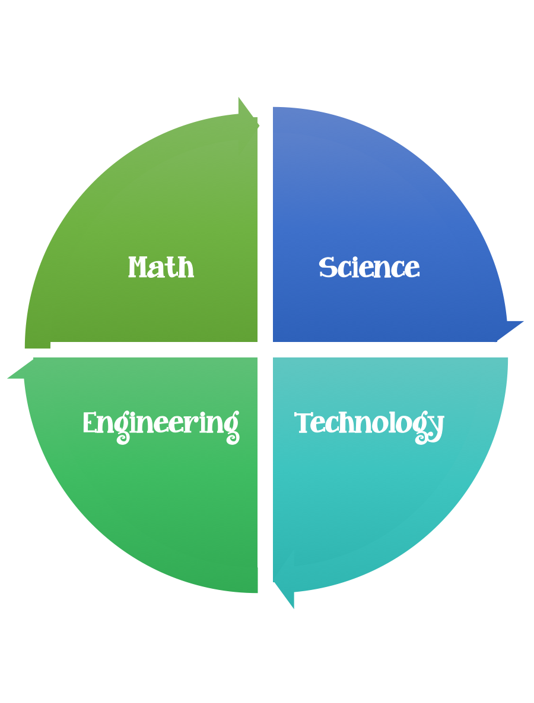
Fulton County STEM Connect
Kindergarten Design Brief

Challenge  Pet Rock | Unit  Rocks, Water, Soil, and Air.
Standard: Prioritized Standard: SKE2.a Obtain, evaluate, and communicate information to describe the physical attributes of earth materials (soil, rocks, water, and air). Ask questions to identify and describe earth materials—soil, rocks, water, and air.
Students should follow the engineering design process.
Background/Problem: There are so many different types of rocks, just like kids. Yet. they are all very special in their own way. Your class has decided to adopt a few rocks for classroom pets. Your teacher needs a way to be able to distinguish them from each other. Can you take care of a pet rock and help your teacher distinguish them from all of the others?
Design Challenge: Students will find a rock of their choice. They will need to give it a bath and dress it. Wiggly eyes will help it see. Possibly a fresh coat of paint will make it feel good about itself. Make sure you brainstorm a design plan before you start/glue. Option: Create a habitat for it. Your pet will also need a name, think of something special/different.
Criteria: Your pet rock needs to have a bath, a fresh coat of paint, wiggly eyes, and hair.

Constraints: You can only use the materials provided to take care of your pet. The name of your pet should be unique. Have your parents help you complete the pet rock sheet.

Materials:
Rock
Wiggle eyes (2)
Silly colored hair/yarn
Tools:
Glue
Scissors
Paint
Markers
Rulers
Pencil
Paper

Optional: (to make habitat)
Small boxes/containers
Shredded tissue paper

