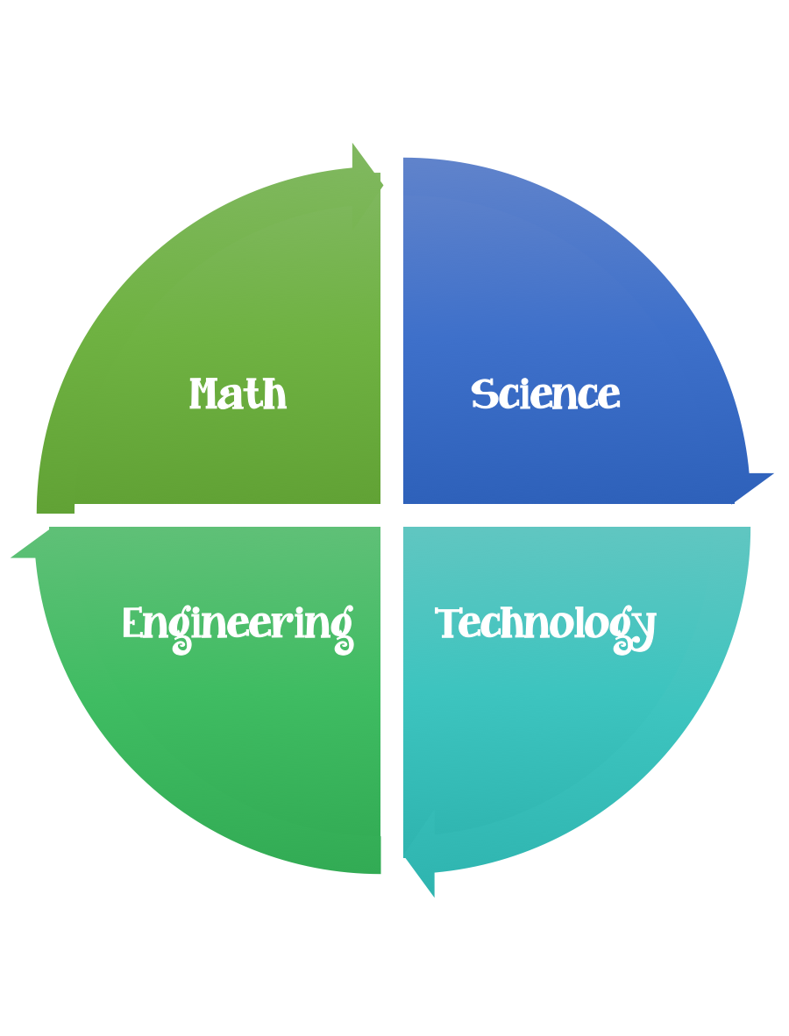
Fulton County STEM Connect
Kindergarten Design Brief

Challenge  Paper Shape Animals | Unit  Parents and Offspring
Standard: Prioritized Standard: SKL2 Obtain, evaluate, and communicate information to compare the similarities and differences in groups of organisms.
Students should follow the engineering design process.
Background/Problem: Watch the story “Gruffalo”. What would you tell your offspring about strolling through the woods alone? What other ways would you take care of them and protect them?
Design Challenge: Create/design characters from the story out of shapes. Can you create the characters from the story out of shapes and be ready to retell the story?
Or just make one?
Criteria: Your characters should be made out of shapes. Think about making them out the same shapes but possibly different sizes. After you make your character can you measure the length and width? Can you find something about a character that you liked? Something that you disliked.

Constraints: You can only use the materials provided.

Options: Brainstorm what worked and what didn’t. What would you do better next time? How did your group work together?

Materials: (per student)
Different sizes of colored construction paper cut into shapes. (Have a parent help with this or have the student cut their own shapes).
Googly eyes

Tools:
Glue
Scissors
Paint
Markers
Rulers
Pencil
Paper
Hole punch

Gruffalo Themed Shape Animals (Just an Idea)-let the students create their own animals without a picture or template.

Once you finish reading the story it's time for a Animal Themed Project. Focus on learning shapes then create the animals out of shapes. When they are all done they can retell the story and the mouse's journey through the forest.

Directions
Using scissors prepare the shapes for your younger child, older kids can prepare themselves.

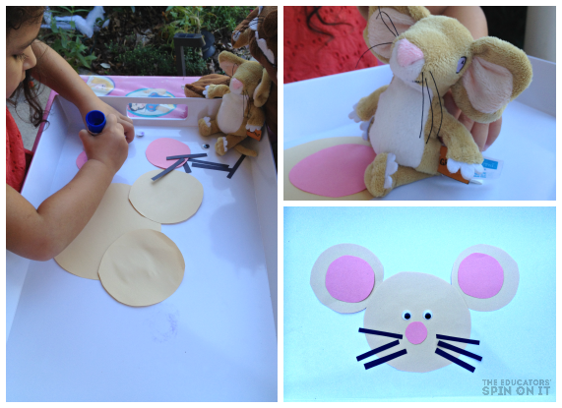

Circle Mouse
- One large circle for head
- Two medium circles for ears
- Two small circles for inner ears
- one small circle for nose
- 6 whiskers

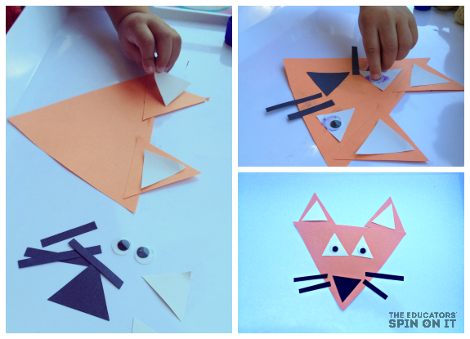

Triangle Fox
- Cut one large triangle for head
- Two medium size triangles for ears
- Four small white triangles for eyes and inner ears
- One small black nose
- Four black whiskers

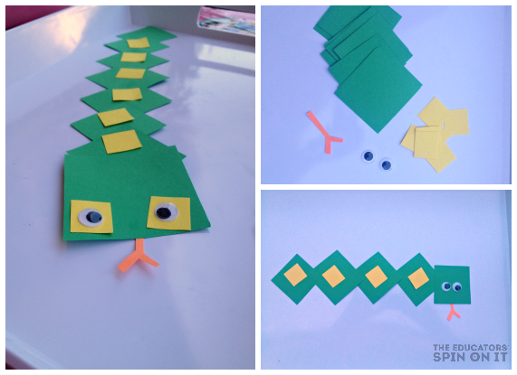

Square Snake
- Seven Green Squares
- One Large Green Square
- Nine Small Yellow Squares
- Orange piece for tongue

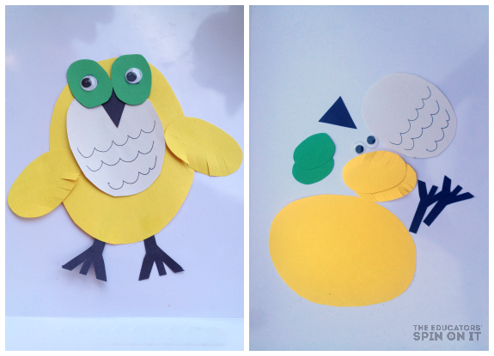

Oval Owls
- One large oval for body
- One medium oval for body
- Two small ovals for wings
- Two ovals for eyes
- One triangle for beak

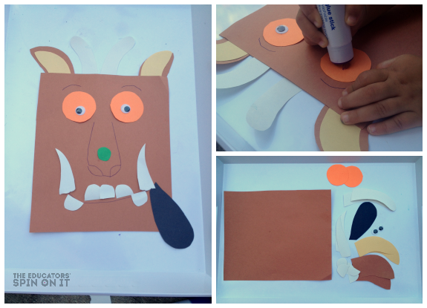

Rectangle Gruffalo
The story itself tells you all the pieces for the Gruffalo from the story... a bet you'll hear your child retelling the story as they build their own Gruffalo

Options:
Interactive Play: Gruffalo Website
http://www.gruffalo.com/in-the-woods/?ReturnUrl=/

Resource found on: http://www.theeducatorsspinonit.com/2015/01/stem-activities-for-kids.html

