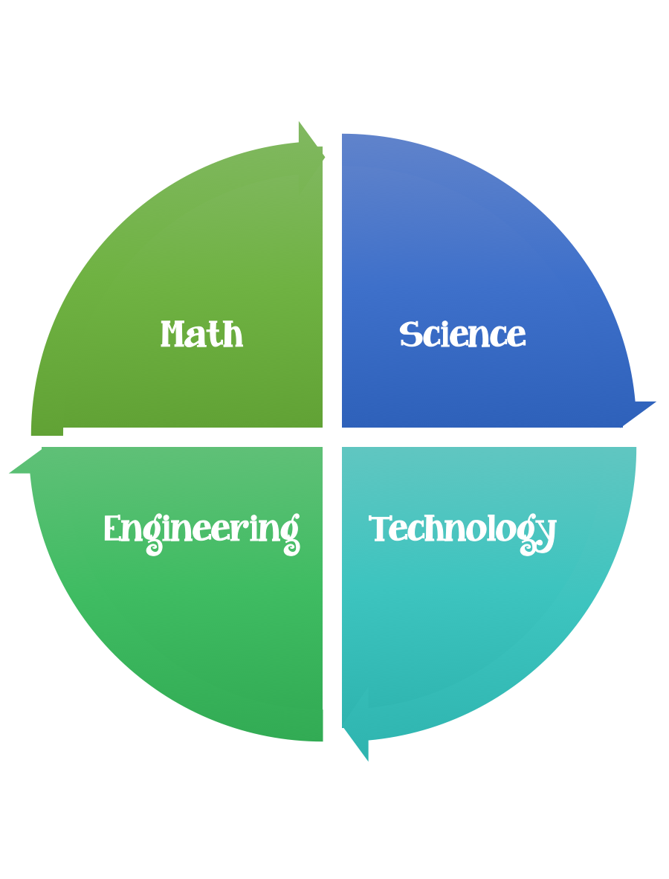
Fulton County STEM Connect
Kindergarten Design Brief

Challenge  Toilet Paper Tube Sail Cars | Unit  Motion
Standard: Prioritized Standard: SKP2.a Obtain, evaluate, and communicate information to compare and describe different types of motion. (While not explicit, the concept of gravity is incorporated into SKP2 when students are investigating the motion of objects in relation to the application of a force. -
Students should follow the engineering design process.
Background/Problem: GMC needs your help designing a wind powered car because the citizens in Johns Creek would like to cut down on their monthly gasoline expenses.
Design Challenge: Students will build a car that is wind powered and that can travel 20 centimeters or eight inches.
Criteria: The car must have four round wheels and two axles. The shape of the sail needs to be able to catch the wind to make it move.
Constraints: The car must be made out of the materials provided.
Materials:
-Toilet paper tubes or paper towel rolls cut in two
-Empty tissue boxes (fun designs to be used as wheels and sails
-Skewer sticks with tips cut off, regular popsicle sticks (plain or colored)
-Masking tape
Tools: Scissors

- Cut the sail and the wheels out of the tissue boxes.
- Poke the skewer through the toilet paper roll and attach the wheels.
- Poke the popsicle stick into the top of the toilet paper roll.
- Attach the sail with the masking tape.
- Options: Paint, draw a person to drive the car and attach.
Possibly ask for parents to precut the wheels or use vanilla wafers.

