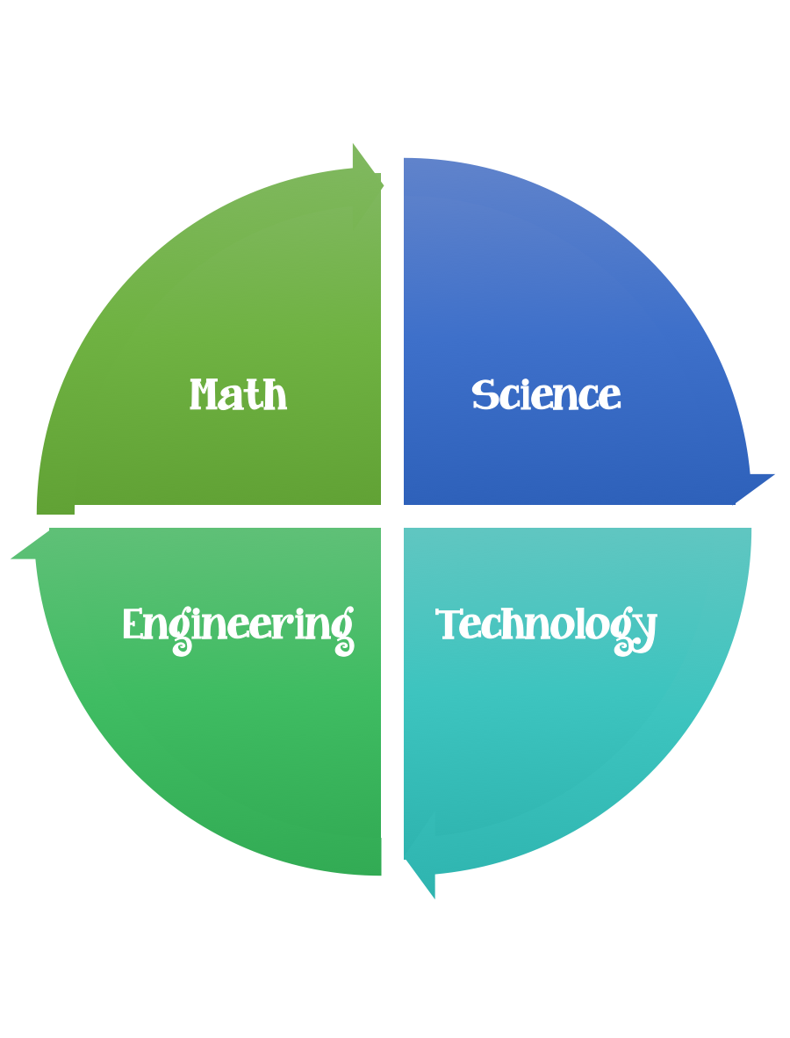
Fulton County STEM Connect
Kindergarten Design Brief

Challenge  Marshmallow and Toothpick Shape Build | Unit  Physical Properties

Standards: Prioritized Standard: MGSEK.G.1 Describe objects in the environment using names of shapes and describe the relative positions of these objects using terms such as above, below, besides, in front of, behind, and next to. Geometry - Identify and describe shapes (squares, circles, triangles, rectangles, hexagons, cubes, cones, cylinders, and spheres).
Students should follow the engineering design process.
Background/Problem: Your teacher needs your help. She cannot remember the names of all the shapes that we have been learning about. Can you build shapes out of toothpicks/spaghetti and mini marshmallows then review their names with her?
Design Challenge: Students will build 2D shapes out of toothpicks/spaghetti and marshmallows and describe their sides and vertices.
Criteria: All eight shapes need to be built. Pick your favorite shape and then complete the attached worksheet.

Constraints: If you were at school you would not be able to eat any of the marshmallows you used in your builds, but because you are at home ask your parents.

Materials: toothpicks or spaghetti, marshmallows
Tools: worksheet and pictures

