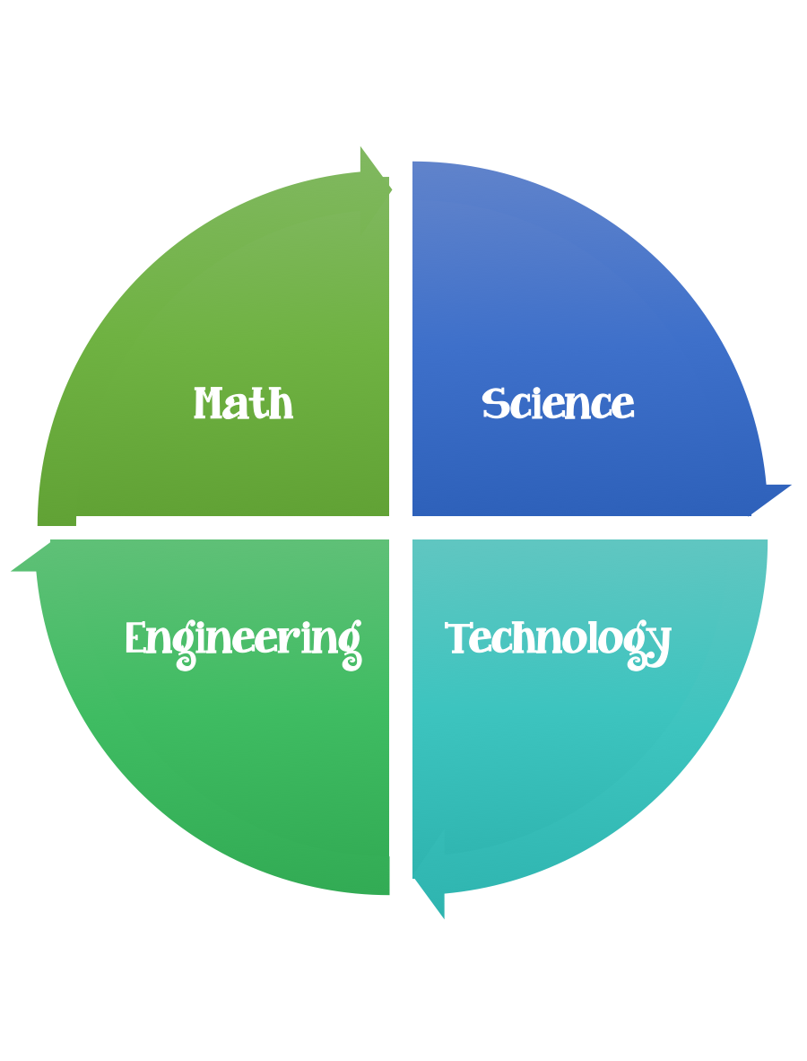
Fulton County STEM Connect
Kindergarten Design Brief

Challenge  Day and Night Sky Diorama | Unit  Time Patterns in Day and Night Sky
Standard: Prioritized Standard: SKE1.b Obtain, evaluate, and communicate observations about time patterns (day to night and night to day) and objects (sun, moon, stars) in the day and night sky.
Students should follow the engineering design process.
Background/Problem: Watch the Chicken Little Fable video.
Design Challenge: Students will create a giant diorama of their own falling sky by making items that belong in the day or night sky. The nighttime items are on top of the table and the daytime items are taped using string to the bottom of the table.
Criteria: Each student should make at least one item for the day sky and one for the night sky. Items should be attached in a way that they are standing upright or suspended.
Constraints: Items need to be larger than 6 unifix cubes and shorter than 10 unifix cubes. Items need to be made out of at least two different types of materials.

Materials:

Cotton balls
Construction paper
Pipe cleaners
Popsicle sticks
Items from recycle bin if you have any
String
Clear Tape

Tools:
Crayons
Markers
Ruler
Hole Puncher
Glue
Scissors

Example:

