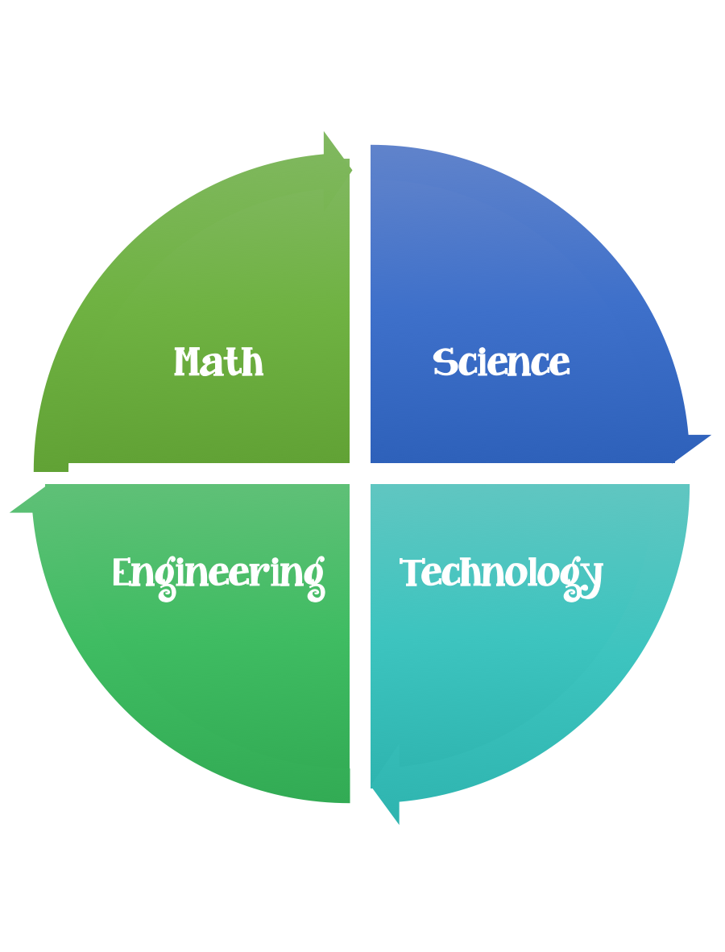
5th Grade Design Challenge
Design Brief

Challenge  Heredity Mix and Match | Unit  Heredity
Standard: Prioritized Standard: S5L2.b Obtain, evaluate, and communicate information showing that some characteristics of organisms are inherited, and other characteristics are acquired. Ask questions to compare and contrast inherited and acquired physical traits.

Learning Objectives:
After this lesson, students should be able to:
- State the number of chromosomes in human body.
- Explain why male and female cells have only half the number of chromosomes found in the body cells.
- Give a brief definition for allele.
- Explain the difference between dominant and recessive alleles and give an example.

Students should follow the Engineering Design Process.
Background/Problem:
In a class discussion format, students are presented with background information about basic human genetics. The number of chromosomes in both body cells and egg and sperm cells is covered, as well as the concept of dominant and recessive alleles. As an example, students determine whether or not they possess the dominant allele for the tongue-rolling gene. This engineering curriculum aligns to Next Generation Science Standards (NGSS).
Vocabulary:
allele: One form of a gene that can occur in two or more forms; for example, three different alleles code for a protein found on the surface of red blood cells, giving rise to the A, B and O blood types.
dominant: A visible or otherwise observable gene for a trait that can mask a recessive form of the same gene.
hemoglobin: The iron-containing protein found in red blood cells that carry oxygen.
meiosis: A type of cell division in which one cell undergoes two divisions, resulting in four new cells, each containing half the amount of genetic material that was in the original cell. Meiosis is a form of sexual reproduction.
mitosis: A type of cell division in which one cell divides into two new cells, each genetically identical to the original cell. Mitosis is a form of asexual reproduction.
recessive: A gene for a trait that can be masked or hidden by a dominant form of the same gene.

E

Lesson Activity Overview:
Students randomly select jellybeans (or other candy) that represent genes for several human traits such as tongue-rolling ability and eye color. Then, working in pairs, students randomly choose new pairs of jellybeans from those corresponding to their own genotypes. The new pairs are placed on toothpicks to represent the chromosomes of the couple's offspring. Finally, students compare genotypes and phenotypes of parents and offspring for all the pairs in the class. In particular, they look for cases in which parents and offspring share the exact same genotype and/or phenotype and consider how the results would differ if they repeated the simulation using more than four traits.
This engineering curriculum aligns to Next Generation Science Standards (NGSS).

Engineering Connection:
An evolving understanding of genes is currently leading genetic engineers to develop treatments to cure genetic disorders.
Does anyone know how many chromosomes humans have in their cells?
In nearly all the cells in the body are 46 chromosomes and they come in pairs. Two of the 46 chromosomes "match," that is, they both contain the same number and types of genes.

For example, both might contain the many genes needed to build the eyes during fetal development, and the genes to produce several different enzymes needed for digestion, and the genes needed make the hormone insulin.
A different pair of chromosomes would contain different sets of genes, such as the genes that determine hair color, or the genes that allow hemoglobin to be made in red blood cells. Twenty-three pairs are the "correct" number of chromosomes.
These chromosomes contain all the genetic information needed for the body to construct all the necessary structures and perform all the necessary functions.
Has anyone has ever told you that you look like your mother or father?
"If we get our genes from our parents, why don't girls end up looking exactly like their mothers did at the same age, and why don't boys look just like their fathers did at the same age?"
You will soon get a chance to see for yourself why you don't look exactly like your same-sex parent. Instead, we will see why we inherit some of our physical features from our mothers, and some from our fathers.
Lesson Intro:
Can you roll your tongue, that is, stick your tongue out and curl up the long edges so the tongue almost forms a cylinder?
If you can’t not to worry, many genes come in two forms.
Somewhere in all the genes that give the instructions for making the muscles of the tongue, there is one that either does or does not enable the tongue to be rolled.
Everyone has two copies of this gene. One copy originally came from the father and the other came from the mother.
Everyone who got two copies of the tongue rolling gene—one from mom and one from dad—can roll their tongues.
Those who got two copies of the non-rolling gene, however, cannot roll their tongues. Because this gene comes in two forms, we call the two forms alleles. In this case, there is a rolling allele and a non-rolling allele of the tongue rolling gene.
What do you think would happen if you got a rolling allele from mom and a non-rolling allele from dad?
Possibly, you would only be able to partially roll their tongues. Can any of you only partially roll your tongue?
Since no supporting evidence can be found, if you possessed one of each allele, you would, in fact, be able to roll your tongue just as well as someone who had two copies of the rolling allele. This is because the rolling allele is dominant over the non-rolling allele. The non-rolling allele is called recessive because its effects can be hidden by the presence of just one rolling allele.
Why it is that some of you cannot roll your tongues. If two recessive alleles are present, then no dominant allele exists to hide them. Thus, anyone with two non-rolling alleles will not be able to roll his or her tongue.
Criteria:
- Your design should be illustrated and the labeled.

Constraints:
- Make sure you have a design plan before you start.
- You may use some or all of the materials listed.

Materials:
- 4 brown paper lunch bags
- Sturdy toothpicks (plastic cocktail-type ones work especially well)
- Red and pink jellybeans to represent tongue rolling alleles (other types of candy, such as gum drops and/or miniature marshmallows may be substituted, and other color combinations may be used for this and the next three items)
- Purple and white jellybeans to represent eyelash length alleles
- Black and blue jellybeans to represent eye color alleles
- Orange and yellow jellybeans to represent ear lobe attachment alleles
- 1 sheet of construction paper any color

Tools:

- Transparent tape
- Paper/pencil for design planning

Example:
Attached Earlobe Detached Earlobe
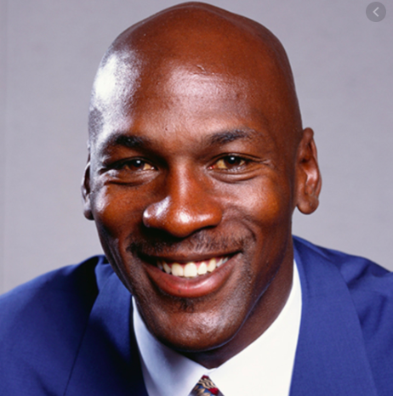
Design Challenge:

Pre-Req Knowledge
A familiarity with dissolved organic matter and a general understanding of conventional drinking water treatment processes, as presented in the associated lesson, All About Water!

Introduction/Motivation
- In this activity, we are going to act like environmental engineers, responsible for delivering clean drinking water to a community. But first, we will make water dirty!
- To make dirty water, we are going to leach organic matter from soil. Does anyone know what a leech is? A leech is a bug that sucks blood, and just like a leech sucks blood, we are going to suck the organic matter from soil! We are leaching organic matter to simulate a natural stream or groundwater drinking source. All-natural bodies of water have organic matter in them—it's just the amount that differs.
- Our simulation will be helpful in showing the hardships of cleaning water that contains high organic matter content. You will each be given a plastic bag and will put soil and water in the bag and let it sit for several days. After the water is nice and dirty, you will design and build water filters and see how clean you can get the water!

Copyright
© 2013 by Regents of the University of Colorado; original © 2004 Duke University

Contributors
Mary R. Hebrank

Supporting Program
Engineering K-PhD Program, Pratt School of Engineering, Duke University

Acknowledgements
This content was developed by the MUSIC (Math Understanding through Science Integrated with Curriculum) Program in the Pratt School of Engineering at Duke University under National Science Foundation GK-12 grant no. DGE 0338262. However, these contents do not necessarily represent the policies of the NSF, and you should not assume endorsement by the federal government.
Last modified: January 21, 2020

