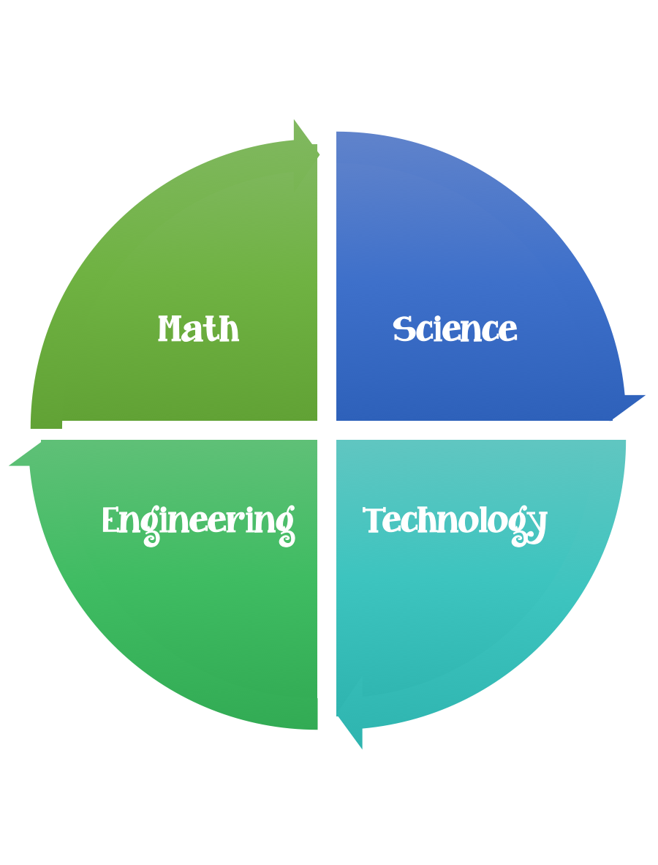
5th Grade Design Challenge
Design Brief

Challenge  Animals and Engineering | Unit  Classification Systems

Standard: Prioritized Standard: S5L1.a Obtain, evaluate, and communicate information to group organisms using scientific classification procedures. Develop a model that illustrates how animals are sorted into groups (vertebrate and invertebrate) and how vertebrates are sorted into groups (fish, amphibians, reptiles, bird, and mammal) using data from multiple sources. Objective: Describe the importance of using classification systems.
Students should follow the Engineering Design Process.
Background/Problem:
Who here has a pet? What type of pet do you have? What categories of animals can you think of?
Let's group these animals into different categories. Example categories: big animals vs. small animals, animals that live inside vs. outside, etc.)
How did you decide on your categories? Did you find things that some of the animals had in common? It is important to be able to classify objects into categories so we can study and understand all the patterns of similarities and differences between different living and nonliving things in the world.
Scientists have developed categories to separate different animals as well. They do this in a similar to what we just did — by finding physical characteristics that are unique to certain groups. Of course, there are other ways to classify animals.
We could have separated the animals into groups by their behavior or how they get their food. For example, some animals are known as predators and others as prey. Have you heard of those before? A predator is an animal that hunts other animals to eat, such as a fox. Prey is the animal that is hunted and eaten, such as a rabbit.
Another way to classify animals is by what type of food they eat. Different animals eat different things. An herbivore is an animal that only eats plants.
A carnivore is an animal that only eats meat or other animals. Would a meat-eating animal be a predator or prey? (Answer: A predator.) What about an animal that eats both plants and meat? We call these animals omnivores. An omnivore is an animal that eats both plants and other animals. (For example: Skunks are omnivores; they eat insects [bees, grasshoppers, larvae], bird eggs, baby birds, amphibians, as well as fruit and berries.) Which type of animal are you?

Now, why would an engineer care about animals?
Engineers work with animals in many different ways. Some engineers study specific animals in great detail and then imitate them to design a technology for use by humans. For example, chemical engineers look at sharks and how they defend themselves from bacteria in the ocean to create new antibiotics to keep humans healthy. The tuna inspired a new sea-going vessel that takes less energy to move. The wings of an airplane were originally designed after the wings of a bird. We call this biomimicry.
Environmental engineers want to protect animal homes for all kinds of animals, from fish to elephants. They might be involved in environment and resource management, and design technologies to help restore a habitat that was destroyed by natural or human caused disasters. They might work on an environment that has been wrecked by a flood or tornado, or a river that was polluted by a factory. It is important that engineers learn as much as possible about the animals they are working to protect. They must know what types of food each animal in that environment eats as well as its interaction with other animals and its ecosystem.
One way that engineers study how animals interact in an ecosystem is by creating a model of it. A biodome is a model that is designed to represent a particular environment and the community of organisms that live there. When constructing a biodome, engineers must be very careful with interactions between animal predators and prey. Why?
Design Challenge:
Nature exists through a delicate balance of predators and prey. Animals and plants are interdependent on other species to ensure their existence.
A change in one population has an effect on all the other populations in the food chain. For example, grasshoppers eat grass, frogs eat grasshoppers, and snakes eat frogs.
If there were so many grasshoppers that there was not enough grass for them to all eat, some grasshoppers might starve and die. A reduction in the grasshopper population would mean that less grass would be eaten. A smaller grasshopper population would also mean that there was less food for the frogs, and that some of the frogs might die. With fewer frogs the grasshopper population may increase. It may not be good to put animals in the biodome that are eaten to extinction by the other animals.
Engineers incorporate predators and prey into their biodomes to provide the necessary environment and foods for animals and plant to survive in balance.
Refer to the Biodomes Engineering Design Project: Lessons 2-6 activity to have students draw connections from past lessons and to demonstrate their understanding of designing for the basic needs of animals.
Today, we are going to learn a little more about animal classification and animal interactions. This will help us think like engineers who are working to design or protect a specific environment.
Criteria:
If you were able to design an environment, what would it look like?
Would it have plants and animals in it? Which ones? How would you decide how many plants and animals you would put in your environment?
Would you also live in your environment? How would you get the right amounts of air, water and food for each of your plants and animals?
Well, engineers actually design artificial environments that consider all of these things. These environments are called biodomes. A biodome is a model that is designed to represent a particular environment and the community of organisms that live there.

Biodomes are used to study ecosystems and attempt to model how living and nonliving things interact in those natural environments. The goal of a biodome is to create an environment that has enough resources for every plant and animal, creating a balance or equilibrium. Engineers come up with all sorts of cool designs using the engineering design process and eventually they settle on one to create.

Constraints:

- Make sure you have a design plan before you start.
- You may use some or all of the materials listed.

Materials:
- Biodomes Engineering Design Project Workbook: Lessons 2-6
- 2 plastic containers (1- and 2-liter bottles with lids work well, or other inexpensive clear plastic trays, bowls, covers and lids)
- seeds
- soil
- sand
- supply of miscellaneous materials, such as pebbles, rocks, wire, small paper cups, plastic wrap, string, foil, popsicle sticks, chopsticks, etc.
- Insects if available, found from outside

Tools:

- masking tape
- duct tape
- glue
- scissors
- exacto knives (a teacher/parent needs to cut the plastic bottles)
- butterfly nets and/or jars and paper cups (to catch and hold insects and worms)
- drill (to make a hole in plastic bottle lids) A piece of tin foil canned be used for this instead
- water
- Paper/pencil for design planning

Procedure: (Teacher notes)
Before the Activity
- This activity can be conducted as either a very structured or open-ended design
- Gather materials and make print a copy enough copies of the Biodomes Engineering Design Project Workbook: Lessons 2-6
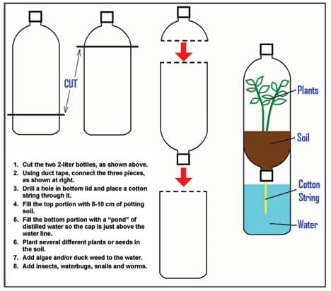

Part 1: Designing Your Biodome
- Give each group a Biodomes Engineering Design Project Workbook: Lessons 2-6.
- Have students decide on a name for their engineering design team (and record it on the first page of their workbook).
- Instruct the students to brainstorm ideas on what a biodome would contain for a given environment. (Provide teams with an environment, perhaps the local environment.)
- After the students have brainstormed their ideas and shared a few with the class, have them pick one of their ideas from which they will build their team's model biodome.
- Next, have students draw a picture of their biodome design in the space provided in their workbooks. (Note: For a simple biodome structure, follow the Figure 1 instructions, have students design uniform biodomes, and provide them with a variety of materials, soils and seeds for the interior. For a more open-ended project, instruct the teams to creatively design their own biodome structures and materials [see Figure 2].)
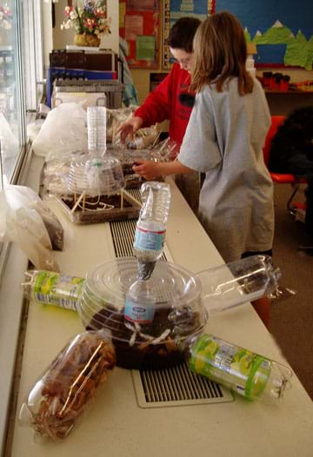
Figure 2. Students are creative in their open-ended model biodome designs.
copyright
Part 2: Building Your Biodome Structure (for Biodomes unit, Lesson 2)
- During this class period, provide each group with the supplies they need to build the structure of their designed biodome.
- Provide time for the students to build their biodome structures. Remind them that they need a tight seal on their biodome, so that it becomes a completely contained mini-environment (use tape or hot glue, preserving the ability to open/close the biodome for future steps).
- Have students answer the questions in Part 2 of the workbook. Remind them that engineers often encounter challenges many times during the engineering design process, before they achieve a finished product.
Part 3: Energy Flow in Your Biodome (for Biodomes unit, Lesson 3)
- Instruct students to sit together with the members of their engineering design teams.
- In their workbooks, have students explain their biodome environment and make a list of the organisms that could be found if their biodome was built on a larger scale.
- Next, have students draw one or more food chains or food webs to show the flow of energy through their biodome environment. Have them consider the relationships of the food sources and consumers in their individual biodomes.
- Have several student teams share their food chains or food webs with the class. Discuss the flow of energy through each of their model biodomes.
- Engage the students in a class discussion about their biodomes. Questions: From where does the energy to sustain your biodomes originally come? (Answer: The sun.) How will you make sure that sunlight gets into your biodome? Where are the air and water sources for your biodomes?
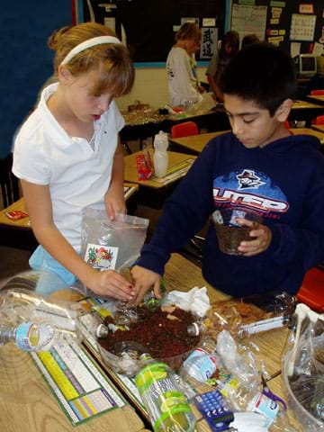
copyright
Part 4: Plants in Your Biodome (for Biodomes unit, Lesson 4)
- Instruct students to sit together with the members of their engineering design teams.
- Discuss basic plant needs with the students (food, water and energy from the sun).
- Have students place soil, sand, rocks, ponds, or earth features into their biodomes, according to their designs.
- Next, have students plant several seeds in the soil of their biodomes.
- Remind students to record in their workbooks what they are adding to their biodomes.
- Next, have students water their biodome and seal it up tightly.
- Ask students to review their food chain drawings and the plants they placed inside their biodomes. Will these plants support their food chains? If not, what changes will they need to make to their food chains? Tell them that engineers often have to make adjustments to their projects as they learn new information or change their materials (in this case, seeds) from their original design.
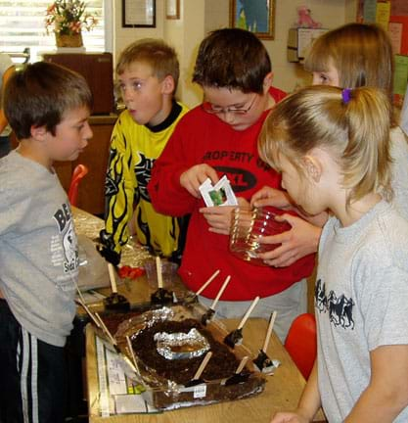
copyright
Part 5: Animals in Your Biodome (for Biodomes unit, Lesson 5)
- Instruct students to sit together with the members of their engineering design teams.
- In their workbooks, have student record observations of what happened to their biodome since they last added something.
- Inform the students that today they will collect animals from outdoors to place into their biodomes. Before they go outside to collect the animals, they need to plan what kind of animals they can have inside.
- Make a list on the board of possible animals (insects) that the students may find to put in their biodome. (Ideas: grasshoppers, crickets, snails, ants, flies, moths, box elder bugs, June bugs, water bugs. Worms will be added in the decomposition activity, Part 6.) Also make a list of food sources that those animals require.
- Ask the students what kinds of problems they might have in picking which animals to put inside the biodome. Explain that they do not want the animals to be eaten by the other animals in the biodome. If this happens, all the animals would die once their food source is gone. Also explain that engineers are often limited by the materials that are available to them. In this case, the students are limited to the animals they can find outside their classroom, mostly insects.
- After giving instructions on outdoor policies, give the students some time go outside with nets and jars to collect insects for their biodomes.
- Returning to class, ask the students to place their insects/animals into their biodomes and observe what they see.
- Have students add water, if needed, to their biodome and seal it up tightly.
Part 6: Decomposers in Your Biodome (for Biodomes unit, Lesson 6)
- Instruct students to sit together with the members of their engineering design teams.
- In their workbooks, have student record observations of what happened to their biodome since they last added something.
- Inform the students that today they will collect worms from outdoors to place into their biodomes. The worms help to break down animal and plant wastes into more useful soil and nutrients.
- Ask the students what kind of problems they see with putting animals and plants into a biodome. Lead them to realize that it is very difficult for humans to make a safe atmosphere for all the different types of plants and animals and that often some of the plants and animals die in their new locations. While the idea of biodomes is a very popular one, there have not been many successes. Engineers work with biologists and other scientists to try their best to design environments in which the animals can live as if they were in nature.
- After giving instructions on outdoor policies, give the students some time to go outside to with jars or paper cups to collect worms for their biodomes.
- Returning to class, ask the students to place their worms into their biodomes and observe what they see.
- Have students add water, if needed, to their biodome and seal it up tightly.
Part 7: Review & Evaluation (after completion of the model biodomes)
- Instruct students to sit together with the members of their engineering design teams.
- In their workbooks, have student record observations of what happened to their biodome since they last added something.
- Have them answer the review and evaluation questions in their workbooks.
- Exhibit the completed model biodomes, along with the completed team workbooks in the school library, display cases or at parents' night.

Vocabulary/Definitions
biodome: A human-made, closed environment containing plants and animals existing in equilibrium.
brainstorming: A technique of solving specific problems, stimulating creative thinking and developing new ideas by unrestrained and spontaneous discussion.
ecosystem: A functional unit consisting of all the living organisms (plants, animals and microbes) in a given area, and all the nonliving physical and chemical factors of their environment, linked together through nutrient cycling and energy flow. An ecosystem can be of any size — a log, pond, field, forest or the Earth's biosphere — but it always functions as a whole unit.
engineer: A person who applies scientific and mathematical principles to creative and practical ends such as the design, manufacture and operation of efficient and economical structures, machines, processes and systems.
engineering design process: The design, build and test loop used by engineers. The steps of the design process include: 1) Define the problem, 2) Come up with ideas (brainstorming), 3) Select the most promising design, 4) Communicate the design, 5) Create and test the design, and 6) Evaluate and revise the design.
model: (noun) A representation of something, sometimes on a smaller scale. (verb) To simulate, make or construct something to help visualize or learn about something else (as the living human body, a process or an ecosystem) that cannot be directly observed or experimented upon.
prototype: A first attempt or early model of a new product or creation. May be revised many times.

Assessment
Pre-Activity Assessment
Discussion Questions: Solicit, integrate and summarize student responses.
- What is an environment? What types of things does an environment include? Can you think of any artificial environments?
- Are you familiar with the engineering design process? Can you name any steps in the engineering design process?
Activity Embedded Assessment
Workbook: Have students follow along with the activity using the Biodomes Engineering Design Project Workbook: Lessons 2-6. Ask the student teams to complete the questions in the workbook after they have finished each part of creating the biodome. After students have finished the workbook questions, have them compare answers with their peers. Review their answers to gauge their mastery of the subject.
Post-Activity Assessment
Re-Engineering: Ask student teams to brainstorm to come up with many ideas on how they could improve their biodomes. Have them sketch the most promising ideas.
Show and Tell: Have student groups show off their biodomes to the rest of the class. Have them explain: 1) how they developed their design, 2) the best part of their design, 3) what could go wrong with it, and 4) what could be fixed or improved in future models. Remind students that engineers go through the design-build-redesign process many times before they are satisfied with a finished product.
Engineering Poster: Using the knowledge they learned in the biodomes lessons and activities, have student engineering teams each create a poster to present their best design for a biodome of a particular environment. Ask them to title their posters with an engineering company name that they invent, such as, Eco Engineering Corporation.

Safety Issues
- Warn students to be careful when cutting plastic bottles. Or, depending on the ability of the students, cut the plastic bottles in advance of the activity.
- Set up a hot glue gun station that either the teacher or a classroom assistant supervises. Do not hand out hot glue guns unless students are able to use them responsibly and safely.
- Be aware of any student allergies to insects, grasses, etc.
- Warn students not to try to capture potentially dangerous insects, such as bees, wasps or spiders.
- Be sure to monitor students when they are outdoors.

Troubleshooting Tips
Limit the materials that students are permitted to use to create their biodomes, otherwise, the biodomes tend to become large and resource demanding. This approach mirrors the real world, in which engineers are usually given size, budget and/or resource limitations. One way to limit size is to set a maximum footprint area, such as one square meter or one square foot.
To give the seeds more time to grow, consider swapping the order of Parts 3 and 4, so the seeds are planted earlier in the model biodome development process.
For Part 5, if insects are not available outside (due to the weather or other limitations), consider purchasing a small supply of crickets or snails (often free since they usually have too many) from a pet store, or potato bugs from a science lab. Note that snails and aquarium plants should not go down the drain or into a nearby stream as both are nasty invasive species. Instead, explain to the students that you'll find a home for them, and then either return them to a suitable aquarium elsewhere or destroy them.

Activity Extensions
Have students conduct research to find out what types of construction methods have been used in real biodomes. See if they can find any details on how these design ideas were reached.
Have students make a bar graph representing the class' biodome diversity.
Have students make a bar chart of the animals and plants they included in their biodomes. Gather all class data and make a class chart as a demonstration. From the data, ask the students how biodome engineers make sure they gather an appropriate sample of plants, animals and decomposers. (Point out that most of students probably gathered the easiest animals and plants to find. What would happen if biodome engineers did this? Would it be a good representation of life?) Then, ask the students to do this for their own biodomes.
Have students research real-world biodomes and find out what animals, birds and fish are inside. How do biodome managers control how the animals come into contact with each other in order to maintain healthy populations of both predators and prey?

Activity Scaling
- For lower grades, adjust the amount of detail required for the biodome design project. You could have the students create identical plant-only biodomes, using the Figure 1 design, or cover only Parts 1, 2 and 4 of the activity.
- For upper grades, there are numerous ways to scale up this project. Give students more constraints on materials and size, and/or come up with other "customer" requirements. Add a math component by requiring them to draw their designs to scale, or measure and graph the growth of their plants, or survival rate of their animals and decomposers. You could also have students design their biodomes using a computer-aided design software application. Require the student teams to present their projects to the class as if they were a professional engineering firm.

References
Biosphere 2. Biosphere 2, Tuscon, AZ. Accessed October 26, 2006. http://www.bio2.com/
Dictionary.com. Lexico Publishing Group, LLC. Accessed October 11, 2006. (Source of some vocabulary definitions, with some adaptation) http://www.dictionary.com

Copyright
© 2004 by Regents of the University of Colorado.

Contributors
Katherine Beggs; Christopher Valenti; Malinda Schaefer Zarske; Denise Carlson

Supporting Program
Integrated Teaching and Learning Program, College of Engineering, University of Colorado Boulder

Acknowledgements
The contents of this digital library curriculum were developed under a grant from the Fund for the Improvement of Postsecondary Education (FIPSE), U.S. Department of Education and National Science Foundation GK-12 grant no. 0338326. However, these contents do not necessarily represent the policies of the Department of Education or National Science Foundation, and you should not assume endorsement by the federal government.
Last modified: August 17, 2020

