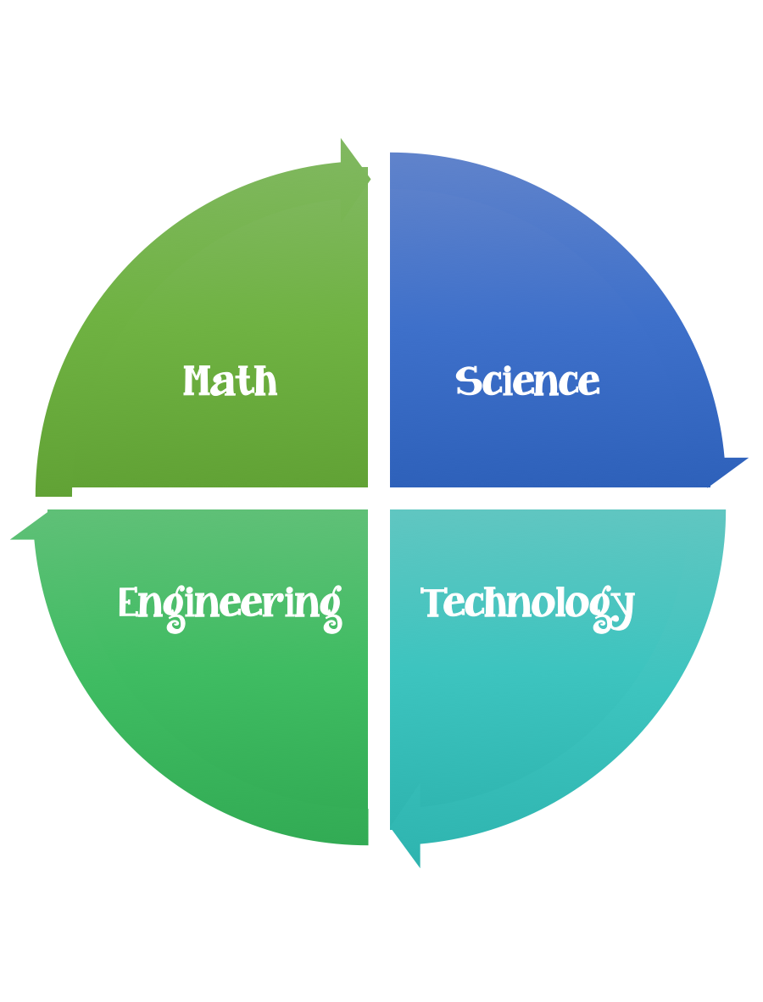
5th Grade Design Challenge
Design Brief

Challenge  Biomimicry | Unit  Plant and Animal Design
Standard: Prioritized Standard: S5L2.b Obtain, evaluate, and communicate information showing that some characteristics of organisms are inherited, and other characteristics are acquired. Ask questions to compare and contrast inherited and acquired physical traits.
Students should follow the Engineering Design Process.
Background/Problem: Engineers often use the natural world as inspiration for design.
Biologically inspired designs include air- and sea-going vessels, navigation tools such as sonar and radar, medical imaging devices, biomedical technologies like prosthetics, and water and pollution treatment processes. Biomimicry has resulted in many creative products, such as a material inspired by the slick leaves of the lotus plant and its natural capacity to wash away dirt particles with every rainfall, and the Velcro hook-and-loop system inspired by the prickly plant burrs that stick to our clothes.
Does anyone know what the word "biomimicry" means? Let's break down the word into more understandable parts. "Bio" means life and "mimicry" means to imitate. So, biomimicry means to imitate life or nature. Who has heard the expression, "Nature knows best"? Well, biomimicry is a way of learning from nature. It is a way to observe nature in action and use that knowledge to inspire new ideas. Engineers often use these ideas to develop cool new products or better ways to do things to help people. Today we are going to learn all about biomimicry and how engineers look at the amazing characteristics of animals and plants to create new or improved product designs.

Can anyone think of an example of biomimicry? Think of something that has been designed with nature in mind. How about Velcro®? Velcro® was invented after a man took a very close look at those little prickly seeds that stick to your clothing when you walk through a field. Water filters are designed like animal cell membranes that let certain things pass through while others are kept out. Also, though planes do not flap their wings like birds, their shapes and the principles of keeping a plane in flight are the same as bird wings. People have also created adhesives that mimic the fascinating and sticky surface of gecko or lizard's five-toed feet. Did you know that? Radar and sonar navigation technology as well as medical imaging was inspired by the echo-location abilities of bats. Also, the solar cells that make up solar panels are designed to mimic the way leaves collect energy from the sun.
Engineers definitely look to nature for inspiration and learning opportunities! Another way that engineers learn from nature is to figure out ways to address the pollution that results from making and using products. Nature has a well-defined way of taking care of its "trash," such as dead animals and leaves. Everything in nature is used, even its waste products. Sometimes natural "waste" becomes food for other animals or breaks down into soil nutrients available for reuse. This is a very important model for engineers; we can learn from nature to recycle our resources and not leave a contaminated mess behind every time we make something.
Biomimicry is a process in which you ask the question, "What would nature do here?" Today we are going to be design engineers who use the biomimicry of animals to come up with a new invention! Are you ready?

Example inventions based on or inspired by animals:
- Airplanes modeled after birds (wing and body shapes, falcon beak)
- Morphing airplane wings that change shape according to the speed and length of a flight, inspired by birds that have differently shaped wings depending on how fast they fly
- Fish-inspired scales that easily slide over each other to enable the morphing airplane wings
- Boat hulls designed after the shapes of Fish
- Torpedoes that swim like tuna

- Submarine and boats hull material that imitates dolphin and shark skin membranes
- Radar and sonar navigation technology and medical imaging inspired by the echo-location abilities of bats
- Swimsuit, triathlon and bobsled clothing fabric made with woven ribbing and texture to reduce drag while maintaining movement, mimics shark's skin
- Adhesives for microelectronics and space applications inspired by the powerful adhesion abilities of geckos and lizards
- Water filters designed like animal cell membranes to let certain things pass through while others are kept out
- Running shoes with technology learned from studying the mechanics of animal feet
- Super strong and waterproof silk fibers made without toxic chemicals by spiders
- Ceramics and windshields, after the mother of pearl material made by abalone mussels
- Underwater glue for slippery surfaces, as made by mussels
- Anti-reflective, anti-glare film used for flat panel displays, touch screens, lamps, and phone and PDA lenses replicate the nanostructures found in the eyes of night flying moths
- A better ice pick for mountain climbers designed after the woodpecker.
- Glow sticks made with light-up chemicals, just like fireflies
- Very efficient pumps and exhaust fans applying the spiraling geometric pattern found in nautilus seashells, galaxies and whirlpools
Example inventions based on or inspired by plants
- Hook and loop material (Velcro®) inspired by cockleburs
- Solar cells inspired by plant leaves (photosynthesis, capturing energy from sunlight)
- A wind-driven planetary rover design that maximize drag, learned from the tumbleweed
- Self-cleaning exterior paint, tiles, window glass and umbrella fabric inspired by the slick leaves of the lotus flower plant and its natural ability to wash away dirt particles in the rain

- Reduced-drag propeller designs inspired by the spiral shape of kelp, which moves with the current rather than fight it, so much less energy is required to move water or ship
- Filter and clean water like a marsh
Criteria: Your design should be illustrated and the labeled.

Constraints:
- Make sure you have a design plan before you start.
- You may use some or all of the materials listed.

Materials:
Each student needs:
- paper
- pencil
- markers or colored pencils
- ruler
Tools:
- Scissors
- Staplers
- Hole punch
- Rulers
- Tape
- String
- Glue
- Paper/pencil for design planning

Design Challenge:
- List three things YOU have as common interests. These interests can be anything; examples: sports equipment, music, clothes, games, furniture, cars, etc.
- Next, agree on one of those common interests for YOUR design topic area.
3. You will have 10 minutes to brainstorm to come up with possible ideas for designs within their interest topic using biomimicry of animals. Can you think of any animals that remind you of your topic? What unique features do those animals have? How could they design something that uses those features? This type of brainstorming and building on each other's ideas is an important step in engineering a new, innovative product.
4. Get your supplies, paper, rulers, markers and colored pencils.
- You will have 20 minutes to design and draw your new product that uses biomimicry. Be as detailed as possible. Label parts and materials in their design.
- Once they have finished design, have each team make a list of the special features of their design and which animal(s) inspired those features.
- Mount the drawing and design features onto a piece of construction paper.
- If time, have students role-play engineering companies and present their biomimicry designs to the class. Post their completed designs in this Flipgrid

Vocabulary/Definitions
biodome: A human-made, closed environment containing plants and animals existing in equilibrium.
biomimicry: Copying or imitating the special characteristics of naturally existing things (animals, plants, etc.) in human-made designs, products and systems. From bios, meaning life, and mimesis, meaning to imitate.
brainstorming: A technique of solving specific problems, stimulating creative thinking and developing new ideas by unrestrained and spontaneous discussion.
design: To form or conceive in the mind. To make drawings, sketches or plans for a work. To design a new product. To design an improved process.
engineer: A person who applies scientific and mathematical principles to creative and practical ends such as the design, manufacture and operation of efficient and economical structures, machines, processes and systems.
engineering design process: The design, build and test loop used by engineers. The steps of the design process include: 1) Define the problem, 2) Come up with ideas (brainstorming), 3) Select the most promising design, 4) Communicate the design, 5) Create and test the design, and 6) Evaluate and revise the design.
imitate: To copy or follow as a model or example.
inspire: To be the cause or source of; bring about. An invention that inspired many imitations.
invent: To originate or create of a product of one's own imagination, ingenuity or experimentation. To invent the iPod.
mimic: To imitate or copy.

model: (noun) A standard or example for imitation or comparison. (verb) To simulate, make or construct something to help visualize or learn about something else (as the living human body, a process or an ecosystem) that cannot be directly observed or experimented upon.

Assessment
Pre-Activity Assessment
Warm Up: Ask students to come up with an argument that plants, and animals have internal and external structures that function to support survival, growth, and behavior and how those structures can be useful to engineers.
Define it! Ask the class: What is biomimicry? Break down the word to help students guess at its meaning. "Bio" means life and "mimicry" means to imitate, so, "biomimicry" means to imitate life or nature, specifically to help design products and systems for human use. Once the class has come to a consensus, ask volunteers to suggest examples.
Activity Embedded Assessment
Thinking through the Design: Ask the students to identify which feature(s) of their design are inspired by nature. If possible, have them be specific about what type of animal or plant they are mimicking and have them describe inspiration (plant or animal characteristics, etc.).

