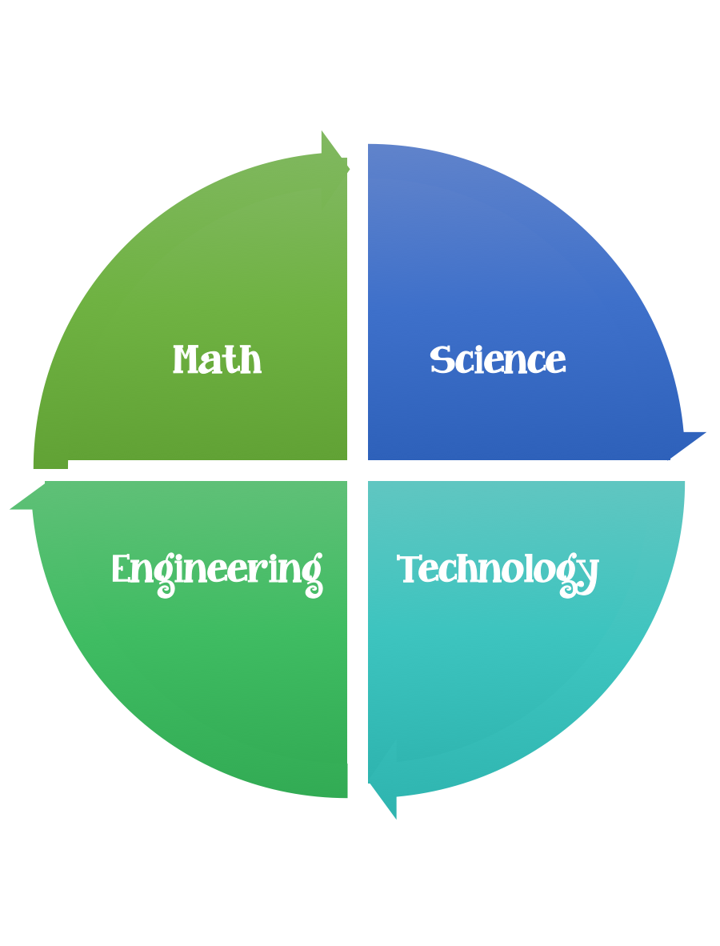
5th Grade Design Challenge
Design Brief

Challenge  All About Water | Unit  Beneficial and Harmful Microorganisms
Standard: Prioritized Standard: S5E1.a Obtain, evaluate, and communicate information to identify surface features on the Earth caused by constructive and/or destructive processes. Construct an argument supported by scientific evidence to identify surface features (examples could include deltas, sand dunes, mountains, volcanoes) as being caused by constructive and/or destructive processes (examples could include deposition, weathering, erosion, and impact of organisms).
Students should follow the Engineering Design Process.
Background/Problem:
Identifying safe and suitable drinking water sources is a common environmental engineering challenge. When identifying potential water sources, engineers must consider the amount of dissolved organic matter (DOM) that is present. DOM can be transformed into various dangerous chemicals when exposed to chlorine that is usually added during the water treatment process. Before water comes out of the tap, it goes through several treatment steps to make sure it is safe for human consumption. Civil, chemical and environmental engineers design these water treatment processes and facilities in cost-effective ways to meet the needs of communities.
From where does the water you drink come? Sure, it probably comes out of a sink faucet or drinking fountain, but where was it before that? Today we are going to learn about different water sources, and how that water becomes safe to drink before it ever comes out of a tap.

All of these topics are extremely important to environmental engineers and will help you understand the source of your water. Engineers are in charge of finding good water sources (environmental engineers), treating that water to make it safe (chemical engineers), and then getting that water all the way to you (civil engineers).
That means, engineers must think about something called water quality, which is a good indicator of how safe water is to drink. Let's get started!
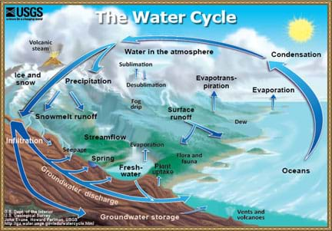
Water is continuously transformed between different phases.
copyright

Criteria:
- Your design should be illustrated and the labeled.

Constraints:
- Make sure you have a design plan before you start.
- You may use some or all of the materials listed.

Materials:
- top half of a two-liter plastic bottle
- coffee filter
- zip-lock sandwich bag
- 2 plastic cups
- A Matter of Leaching Worksheet

- sand
- gravel
- cotton balls
- screening
- activated charcoal or carbon (optional, can be purchased on amazon.com or at some garden centers)
- garden soil, not potting soil
- permanent marker

Tools:
- Scissors
- Staplers
- Hole punch
- Rulers
- Tape
- String
- Glue
- Paper/pencil for design planning

Design Challenge:

Pre-Req Knowledge
A familiarity with dissolved organic matter and a general understanding of conventional drinking water treatment processes, as presented in the associated lesson, All About Water!

Introduction/Motivation
- In this activity, we are going to act like environmental engineers, responsible for delivering clean drinking water to a community. But first, we will make water dirty!
- To make dirty water, we are going to leach organic matter from soil. Does anyone know what a leech is? A leech is a bug that sucks blood, and just like a leech sucks blood, we are going to suck the organic matter from soil! We are leaching organic matter to simulate a natural stream or groundwater drinking source. All-natural bodies of water have organic matter in them—it's just the amount that differs.
- Our simulation will be helpful in showing the hardships of cleaning water that contains high organic matter content. You will each be given a plastic bag and will put soil and water in the bag and let it sit for several days. After the water is nice and dirty, you will design and build water filters and see how clean you can get the water!

Procedure
Background
Students leach organic matter from soil and create water samples with high DOM content by soaking dirt in water. They design and build water filters by layering sand, gravel, cotton balls, screening, activated charcoal and/or soil inside the tops of two-liter bottles. After the water sits for three days, students test to see how effective their filters are at cleaning the dirty water. Then they rebuild their filters to make improvements, and reflect on their designs.
Before the Activity
- Gather materials.
- Cut the two-liter bottles in half.
- Make copies of the attached A Matter of Leaching Worksheet, one per student.
- Divide the class into groups of three or four students.
With the Students
Part 1: Leaching Organic Matter
- Distribute the worksheets.
- Give each group a zip-lock sandwich bag that contains a handful of soil. Have students write their names on their bags in permanent marker.
- Instruct students to make observations about their soil. Prompt students to notice texture, smell and color.
- Fill each bag with warm water until it is approximately three quarters full (see Figure 1).
- Let the bags sit with no disruption for a minimum of three days.
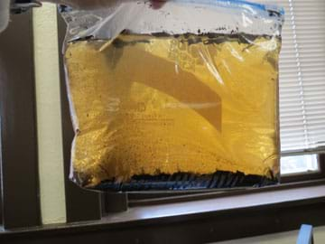Figure 1. Leaching organic matter.
copyright

Part 2: Filtering
- Hand bags back out to students (without shaking).
- Have students make new observations about the contents of their bags. Instruct students to write about their observations on their worksheets.
- Give each student a top half of a two-liter bottle. Pass out one coffee filter to each group, and have students insert the coffee filters into their two-liter bottles tops (see Figure 2).
- List the following materials on the board: sand, gravel, cotton balls, screening, activated charcoal or carbon, and soil. Tell students that their challenge is to work as engineers to make filter that effectively clean the water. They can use any of the materials listed on the board to put onto the coffee filter inside their two-liter bottles tops.
- Have students brainstorm and then sketch filter designs on their worksheets. Their sketches should show the various layers of materials they are going to use. Have students show their designs to the teacher and explain why they think their designs will work.
- Hand out materials and give students time to create their filters.
- After all groups have built their designs, begin testing the filters. Give two plastic cups to each group. Instruct each group to take their bag of dirty water and pour most of it into one of the plastic cups; hold back a bit of the dirty water as a control for final comparison).

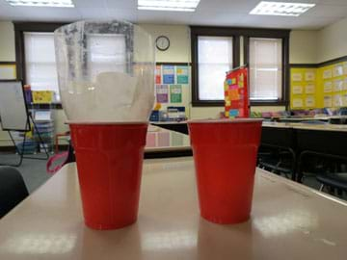
Figure 2. The filtering processes.
copyright

- Have students insert their two-liter bottles and coffee filters into the second, dry cup (see Figure 2). Then, instruct them to pour the dirty water from the first cup into the top of the two-liter bottle, their filter system. Note that, depending on the materials students choose to use for their filters, it might take a good deal of time for the water to exit the filter.
- Have students run the water through their filters three times, each time moving the filtering apparatus onto the empty cup and pouring the excess water on top of the filter.
- Expect students to be able to see a difference between their initial water samples and the final products. Prompt students to think about how well their filters worked. Would you drink this water?
- Have students redesign their filters based on what they've learned so far. Then, instruct them to filter their cleaner water with their improved filtering apparatus two times. Now, students have their final products.
- Have students make observations about their filtered water and write notes on their worksheets. Have students compare their before and after products.
- Compare final products between groups and prompt students to think about why some designs worked better than others. (Expect filters with the most sand and gravel to be the most effective. The longer it takes the water to flow through the filter, the cleaner it will be, due to the fact that the water had more contact time.)

Vocabulary/Definitions
filter: A porous material through which water can pass in order to strain out suspended solids.
filtration: The process of passing through a filter.
leach: Putting water through a sample to remove some constituents.

Assessment
Pre-Activity Assessment
In-Class Questions: Can anyone list the materials used in a drinking water treatment plant filter? (Answer: Sand, gravel and activated charcoal.) How do these materials compare to what we have in class today? (You may not have all the same materials, but you can ask students what they think each of the materials helps with.)
Activity Embedded Assessment
Questioning Designs: When students have finished their designs, have them discuss the pros and cons within their groups to decide on a final design. Circulate around the classroom to listen in on the discussions. When students present their final designs, have them explain their reasoning. Ask questions such as: Why did you decide to place the sand at the top (or other location) of your filter? Do you think that it was a good decision to omit gravel (or another material)? Why?
Worksheet: During the activity, have students complete their worksheets.
Post-Activity Assessment
Reflection: Have one student from each group bring its final water sample to the front of the room. Instruct students to rank water samples from cleanest to dirtiest (explain that they are just basing this off of visual observations, and that many of the solids have been removed from the water samples, but that does not mean the water is really "clean"). Have the groups ranked first and last explain their filter designs, describing how they were made and the order of the materials. Guide students talk about the differences in their filters and decide which materials worked best. Discuss why the dissolved organic matter was not removed very well. (Due to the lack of activated charcoal in the designs, no chemical reactions take place with the DOM. The DOM cannot be filtered out with the students' methods because the molecules are so small. However, they probably did a pretty good job of removing many of the suspended solids!)

Troubleshooting Tips
- Thoroughly wet the sand before making it available for filter building. If the sand is too dry, it absorbs the water instead of filtering it through.
- The more sand in the design, the longer it takes to filter, so limit the amount of sand that students are permitted to use if testing time is limited.
- Make sure the bags of soil and water are sealed tightly and stored in upright positions in order to prevent any spills and messes.
- Do not let students drink their filtered water! Explain that even though the water may look clean, dissolved organic matter still exists in the water and it is not safe to drink. In a real water treatment process, the water would go through many more purification steps before it would be safe for consumption.

Copyright
© 2012 by Regents of the University of Colorado.

Contributors
Jessica Ebert; Marissa H. Forbes

Supporting Program
Integrated Teaching and Learning Program, College of Engineering and Applied Science, University of Colorado Boulder

Acknowledgements
This digital library content was developed by the Integrated Teaching and Learning Program under National Science Foundation GK-12 grant no. DGE 0338326. However, these contents do not necessarily represent the policies of the National Science Foundation, and you should not assume endorsement by the federal government.
Last modified: April 2, 2019

