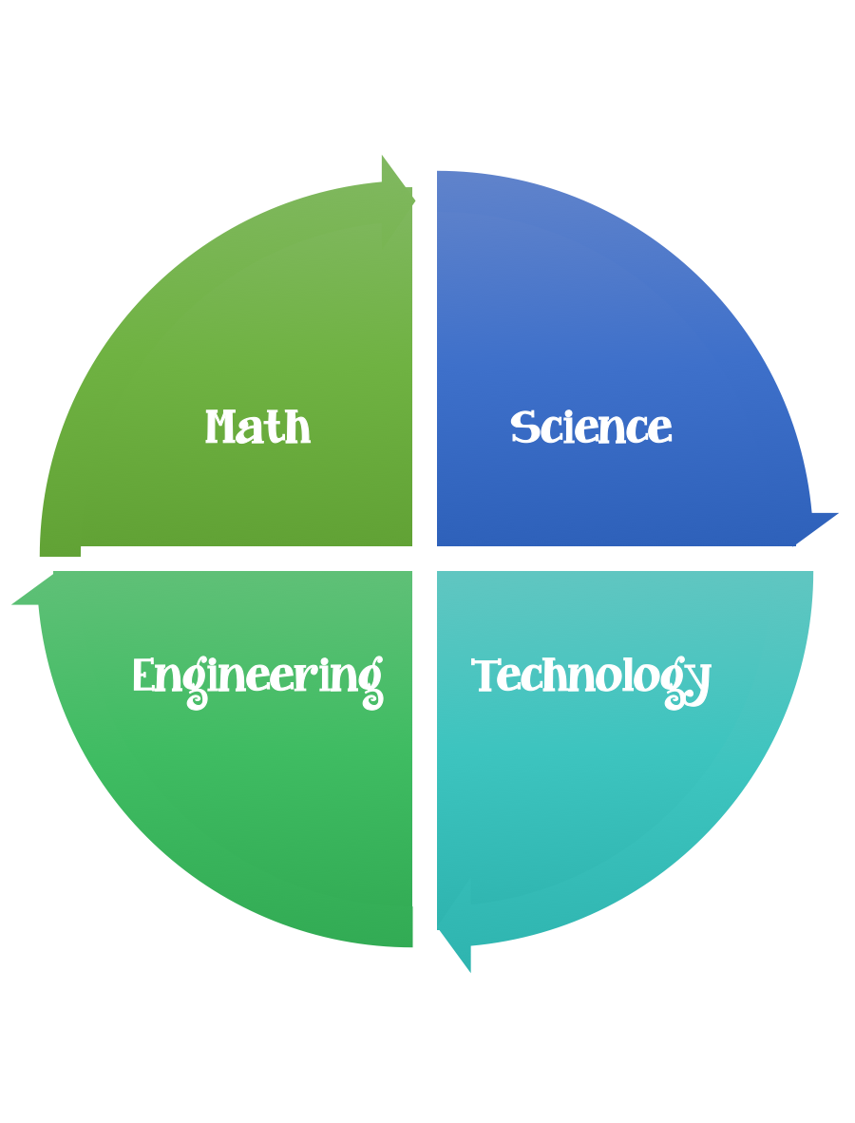
Findley Oaks STEM Challenge
4th Grade Design Brief

Challenge  Water Cycle Design Challenge | Unit  States of Water and the Water Cycle

Standard: Prioritized Standard: S4E3.b Obtain, evaluate, and communicate information to demonstrate the water cycle. Develop models to illustrate multiple pathways water may take during the water cycle (evaporation, condensation, and precipitation). (Clarification statement: Students should understand that the water cycle does not follow a single pathway.)
Students should follow the Engineering Design Process.
Background/Problem:
We have been studying about the water cycle. We have learned about the properties of water and the many ways that we use water. This week our focus is on the water cycle. We need to design a triorama illustrating how the water cycle works to share with others.
Design Challenge:
Your challenge is to design a triorama illustrating how the water cycle works. Please include the provided labels. Your triorama should also include one moving part or a pop up. You will share your water cycle triorama with the class.
Criteria:
Your triorama should:
- include one movable part or one pop-up.
- include the provided labels.
- evaporation, condensation, precipitation, run off
- show how each part of the water cycle works

Constraints:

- Make sure you have a design plan before you start.
- You may use some or all of the materials listed.

Materials:
- White construction paper 12 X18 for folding triorama
- Scrap box materials
- Glue
- Paper fasteners

Tools:
- Scissors
- Crazy scissors
- Staplers
- Hole punch
- Rulers
- Paper/pencil for design planning

Brainstorm ideas…. make sure you are taking the time to plan.

evaporation
Evaporation is a type of vaporization that occurs on the surface of a liquid as it changes into the gas phase.

condensation
Condensation is the change of the physical state of matter from the gas phase into the liquid phase and is the reverse of vaporization.

precipitation
In meteorology, precipitation is any product of the condensation of atmospheric water vapor that falls under gravity from clouds. The main forms of precipitation include drizzle, rain, sleet, snow, ice pellets, graupel (also called soft hail or snow pellets) and hail.
_________________________________________________________
run off
Surface runoff is the flow of water occurring on the ground surface when excess rainwater, stormwater, meltwater, or other sources, can no longer sufficiently rapidly infiltrate in the soil.

