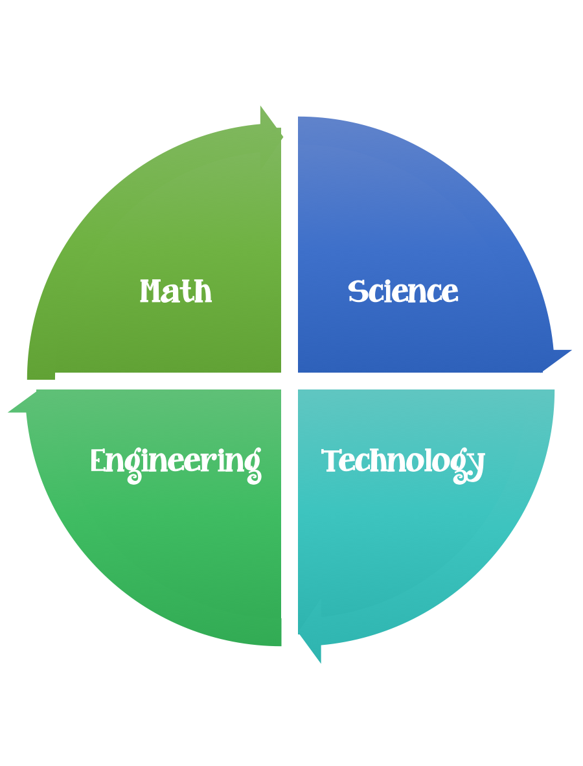
Findley Oaks STEM Challenge
4th Grade Design Brief

Challenge  Rainbow in a Jar | Unit  The Nature of Light

Standard: Prioritized Standard: S4P1.b Obtain, evaluate, and communicate information about the nature of light and how light interacts with objects. Plan and carry out investigations on the path light travels from a light source to a mirror and how it is reflected by the mirror using different angles. P
Students should follow the Engineering Design Process.
Background/Problem:
How many times have you peeked out the window on a rainy day and seen a rainbow (or two)?
Rainbows usually only appear after the rain because the sun's rays bounce off the drops remaining in the atmosphere. As they do, they split into all the colors of the rainbow.
This resembles what you see when you shine light through a prism. The glass splits the white light up into its different frequencies.
In both cases, you need two things: a source of light, and a transparent substance like glass or water.
But wouldn’t it be spectacular to hold a rainbow in a jar?
Everything is made up of teeny tiny things called molecules. Some things have a lot of molecules while others only have a few. The more molecules, the heavier the object. The same idea applies to liquids. The more molecules in a liquid, the “heavier” the liquid. This is known as density.

Design Challenge:
Using colored liquids with different densities, your challenge is to create a rainbow in a jar. You must follow the directions step by step to correctly order the colors of the rainbow.
The order is Red, Yellow, Orange, Green, Blue, Indigo, and Violet (RYOGBIV). When you finish adding the colors to the jar, hold the jar up to the light gently without shaking the contents and see if the colors are separated enough to resemble a real rainbow!
Criteria:
- Pour your ingredients into the middle of the jar!

Constraints:

- Make sure you have a design plan before you start.
- You may use some or all of the materials listed.

Materials:

- 1 jar
- 1/2 cup blue dishwashing liquid
- 1/2 cup olive oil
- 1/2 cup rubbing alcohol
- 1/2 cup light corn syrup
- food coloring
- spoons
- bowls for mixing

Tools:
- tall, see-through container (ex: clean mason jar)
- measuring Cup
- toothpicks
- dropper

Directions:

- Make your purple layer by mixing 1/2 cup of the light corn syrup with 1 drop of blue and 1 drop of red food coloring.
- Carefully pour it into the bottom of your jar.
- Carefully pour the blue dish soap down the side of the jar.
- Mix 1/2 cup of water with 2 drops of green food coloring.
- Carefully pour in your green water down the side of the jar.
- Gently pour 1/2 cup olive oil down the side of your jar.
- Mix 1/2 cup of rubbing alcohol with 2 drops of red food coloring.
- Carefully pour the red rubbing alcohol down the inside of your jar.
- Being careful not to disturb your liquids, set your jar down on the table and enjoy your rainbow!

Brainstorm ideas…. make sure you are taking the time to plan.
What's happening?
Because the different liquids used have a different number of molecules, some are heavier than others. This idea separates the liquids into layers that are easily noticeable. The food coloring dyes each layer to make it seem like a layer from the rainbow.
Even if the contents are shaken up or moved around, over time the jar will return to its original formation because the densities of each liquid will not change. This idea of molecules and densities is the same thing that is seen with oil and water. Oil is “lighter” than water so, such as after an oil spill, it will float above the water!
A rainbow is a multi-colored arc that forms in the sky. Rainbows are created by the bending of light in water droplets in the atmosphere, which results in a spectrum of light appearing. A rainbow is in fact a full circle of light, however, because we view a rainbow from the ground, we only see a semi-circle or arc of the rainbow.
A rainbow is not an object; it cannot be approached or physically touched. No two people see the same rainbow, in fact even our individual eyes see slightly different rainbows. Rainbows can be seen not just in rain but also mist, spray, fog, and dew.

Results:
You should have produced a beautifully layered rainbow in a jar with distinct lines that separate each layer of liquid without them mixing.
Why?
So, what keeps all these layers all separated from each other?
It’s how dense, or heavy, each liquid is. The corn syrup is heaviest and sits nicely on the bottom.
The dishwashing soap is not quite as heavy as the corn syrup, but it’s heavier than the olive oil, and so on.
Layering them from heaviest to lightest from the bottom up ensures that the rainbow maintains its distinct lines.
What if you had added the layers in the reverse order?
Would you still see a rainbow? Try it. What if you changed the colors around but added each liquid in the original order? Go for it.
What happens if you mix your rainbow with a spoon?
No matter which new experiments you attempt, be sure to record your results to learn even more about density.
Post your creation to Flipgrid here.

