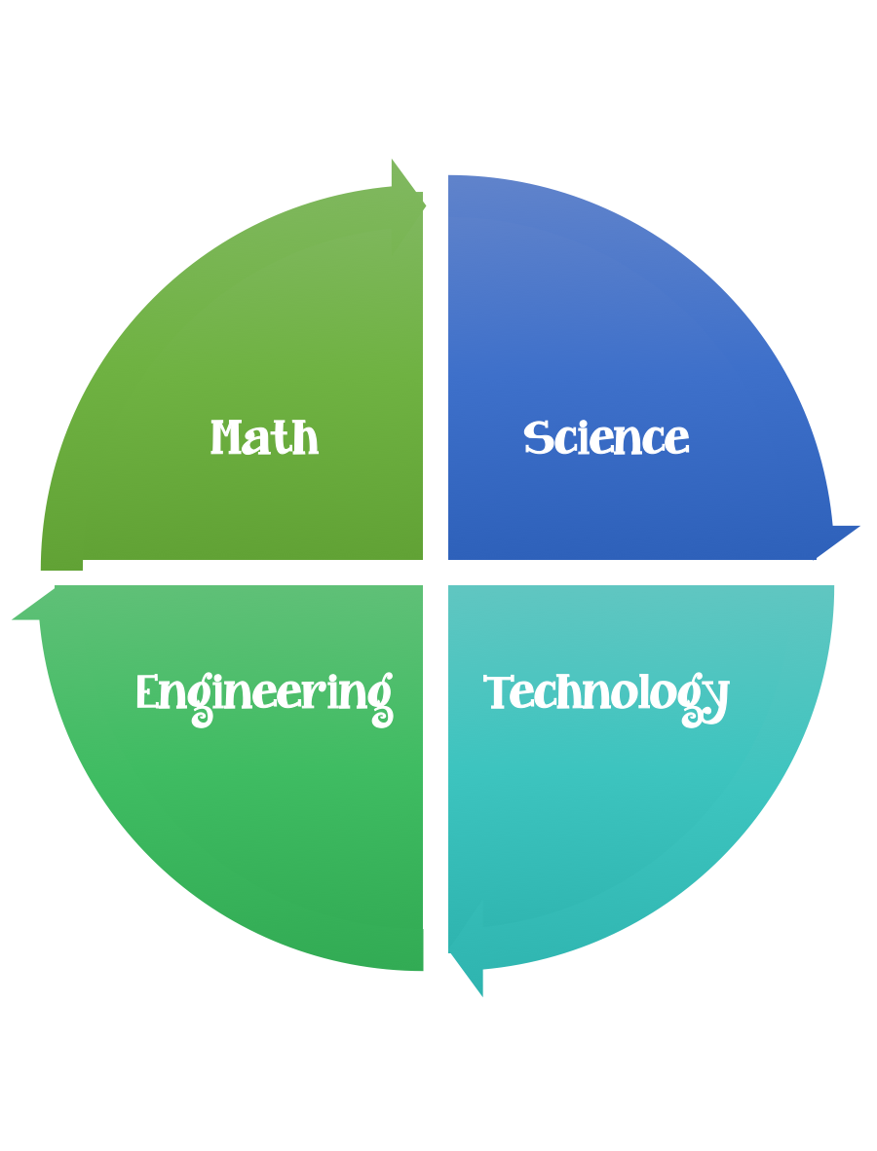
Findley Oaks STEM Challenge
4th Grade Design Brief

Challenge  Make a Comet | Unit  Stars, Star Patterns, and Planets

Standard:
Prioritized Standard: S4E2.b Obtain, evaluate, and communicate information to model the effects of the position and motion of the Earth and the moon in relation to the sun as observed from the Earth. Develop a model based on observations to describe the repeating pattern of the phases of the moon (new, crescent, quarter, gibbous, and full).
Background/Problem:
NASA needs to follow the path of a comet as it makes its way through space while simulating the heat and gravitational effects of the Sun.
Quick Comet Facts:
- No two comets are alike.
- They differ in size, shape, and what they’re made of.
- Comet tails are a result of solar wind.
- Energy and particles from the sun push on the comet.
- This force pushes dust and gas behind the comet. The ion dust and gas have different weights, so they separate, making two specular tails.
- Once scientists saw a third tail, which was a smaller tail forming just between the dust and gas tail.
- They discovered it was made of salt.
- Comet tails have been discovered to be so long that Voyager 2 passed through one that was thousands of miles away!
Design Challenge?
Your challenge is to design a comet and simulate the movement of the comet through the solar system. A comet is a chunk of ice, rock, and gas flying through space. When they get close to the sun, they heat up. We can see their glow and long tails. In this activity, you’ll make your own comet that can fly around the room!

Optional activity:
Go to https://spaceplace.nasa.gov/tails-of-wonder/en/
Play the Tails of Wonder Space Game
Today’s Activity
Make a Comet on a Stick!
Materials:
- Chopsticks or a popsicle stick
- Metallic ribbon (different colors)
- Scissors
- Tin foil

hich is the glowing part around the nucleus. Then they have two tai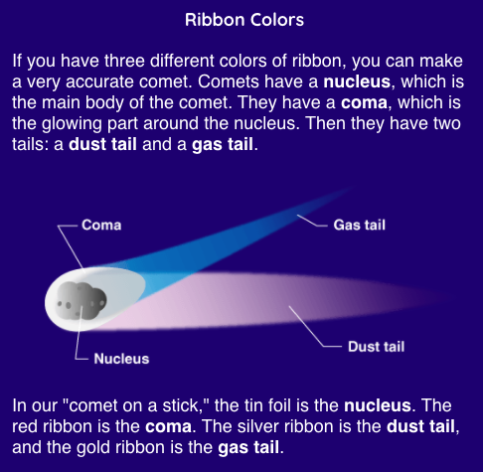ls: a dust tail and a gas tail.

What to do:
- Cut five pieces of ribbon: two long pieces, two medium pieces, and one short piece. If you want an extra long tail, make the long pieces about three feet in length.
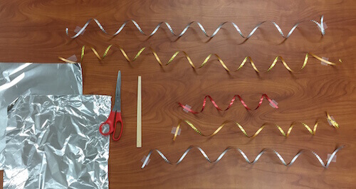
- Tie your ribbons around the end of your chopsticks or popsicle stick. If you want the ribbon to be as long as possible, tie the knot close to the edge of the ribbon.
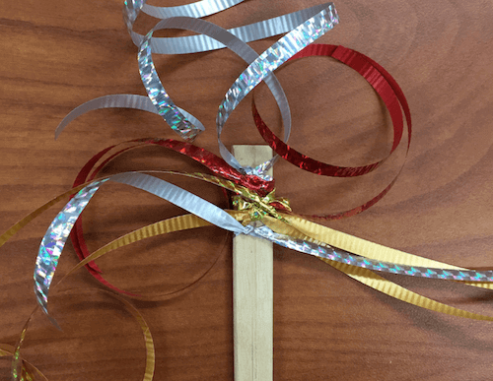

- Cut three pieces of tin foil so they’re roughly square shaped.

- Hold the ribbon pieces off to one side and gather the tin foil around the end of the stick.
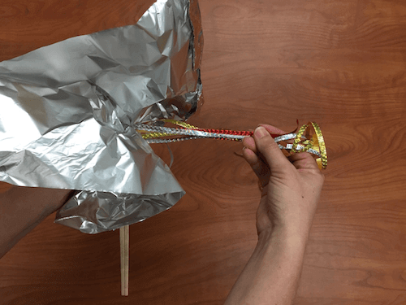
- Form the tin foil into a ball while keeping the ribbon tail off to the side.
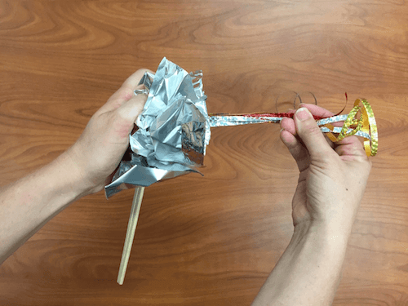

- Repeat with two more sheets of tin foil. Gather it around and form it into a ball. If you want a bigger comet, add more tin foil!
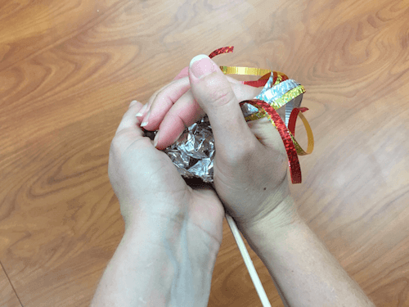
- Take your comet on a stick and fly it around the room!
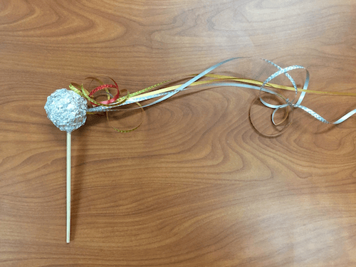

Optional Activity that you can do at home with supervision from an adult.
Your challenge is to design a comet and simulate the movement of the comet through the solar system.
Materials:
The "ingredients" for a six-inch comet are:
- 2 cups of water
- 2 cups dry ice (frozen carbon dioxide)
- 2 teaspoons of sand or dirt
- 1 teaspoon of ammonia
- I teaspoon of corn syrup

Tools:
Other materials you should have on hand include:
- an ice chest
- a large mixing bowl (plastic if possible)
- 4 medium-sized plastic garbage bags
- work gloves
- a hammer, meat pounder, or rubber mallet
- a large mixing spoon
- paper towels
- safety goggles

Directions:
Here are the steps for making a 6-inch comet:
- Cut open one garbage bag and use it to line your mixing bowl.
- Have all ingredients and utensils arranged in front of you.
- Place water in mixing bowl.
- Add sand or dirt, stirring well.
- Add ammonia
- Add corn syrup, stirring until well mixed.
- Place dry ice in 3 garbage bags that have been placed inside each other. Be sure to wear gloves while handling dry ice to keep from being burned.
- Crush dry ice by pounding it with hammer.
- Add the dry ice to the rest of the ingredients in the mixing bowl while stirring vigorously.
- Continue stirring until mixture is almost totally frozen.
- Lift the comet out of the bowl using the plastic liner and shape it as you would a snowball.
- Unwrap the comet as soon as it is frozen sufficiently to hold its shape.

What's happening?
As you watch during the day the comet will start to melt turning directly from a solid to a gas (which is what carbon dioxide does at room temperature and comets do under the conditions of interplanetary space when they are heated by the sun).
For safety, do not touch the comet with your hands, use ice-cream sticks to examine the comet. As it begins to melt, you may notice small jets of gas coming from it. These are locations where the gaseous carbon dioxide is escaping through small holes in the still frozen water. This is also detected on real comets, where the jets can sometimes expel sufficient quantities of gas to make small changes in the orbit of the comet.
After several hours the comet will become a crater-filled ice ball as the more volatile carbon dioxide sublimated before the water ice melts.
Real comets are also depleted by sublimation each time they come near the Sun. Ultimately, old comets may break into several pieces or even completely disintegrate. In some cases, the comet may have a solid, rocky core that is then left to travel around the comet's orbit as a dark barren asteroid.

