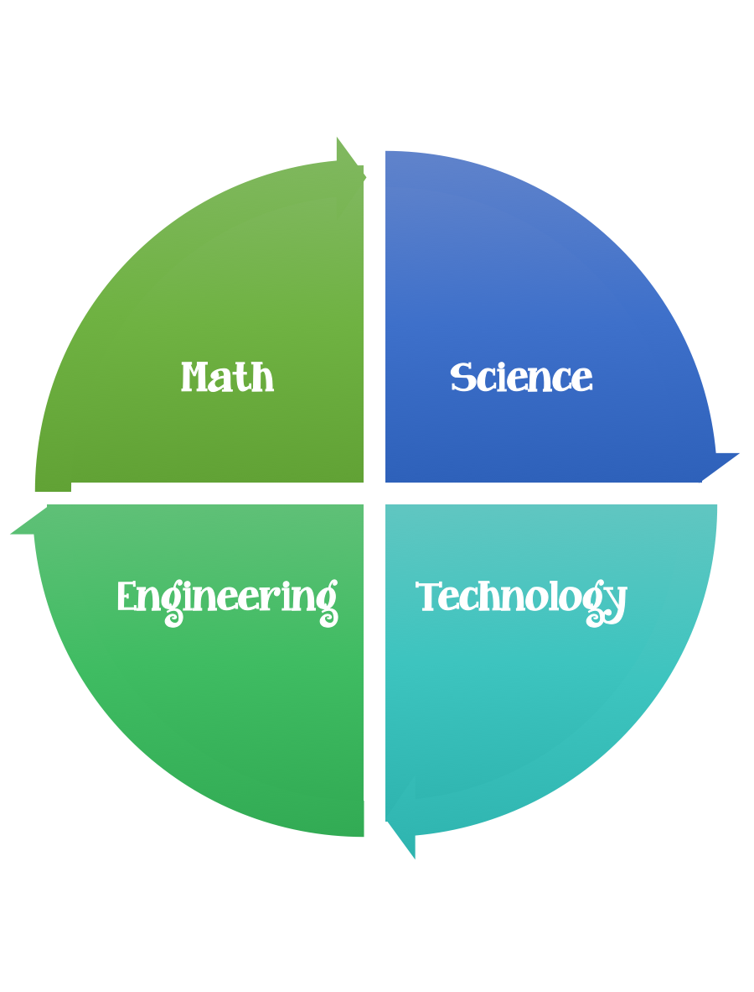
Findley Oaks STEM
4th Grade Design Brief

Challenge  Camouflage | Unit  Survival and Extinction of Organisms

Standard: Prioritized Standard: S4L1.d Obtain, evaluate, and communicate information about the roles of organisms and the flow of energy within an ecosystem.
Students should follow the Engineering Design Process.
Background/Problem:
Animals use camouflage to adapt to their environment. Many animals have colors or markings on their fur, feathers, scales, or skin that enables them to blend in with their habitat (the place where that animal lives).
Camouflage helps an animal survive. Close your eyes and imagine a motionless green frog at the edge of a pond. brown feathers on a female bird siting on their eggs, the arctic fox who has white fur in the winter and brown fur in the summer.
Design Challenge:
To demonstrate your understanding of camouflage your challenge is to choose either a snake, butterfly, or iguana template, camouflage it and make it blend in/hide somewhere on a wall or in a room of your house. (simulation-blend into its habitat)

Criteria:
Your animal should:
- be either a snake, butterfly. or iguana
- hidden in the pretend wild habitat; select a specific home
- be colored with markers, crayons, or colored pencil so that it will be camouflaged in the habitat selected
- be placed in their habitat without burying them. They must be open, hidden only by their coloring and patterns

Constraints:

- Make sure you have a design plan before you start.
- You may use some or all of the materials listed.

Materials:

- Paper butterfly, snake, or iguana pattern (Download below) or print this design brief, they are at the bottom.
Butterfly
Snake
Iguana

Tools:

- Markers
- Crayons
- Colored Pencils
- Clear Tape
- Paper and pencils to plan.

Brainstorm ideas…. make sure you have a plan.
Post your challenge results to Flipgrid here.

