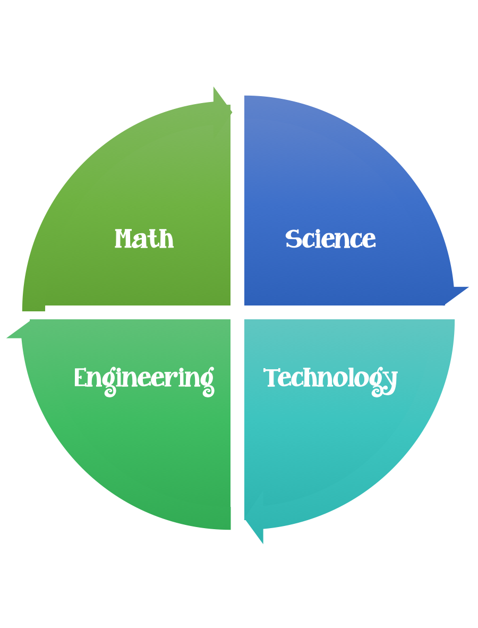
Findley Oaks STEM CHALLENGE
4th Grade Design Brief

CHALLENGE  Balloon Powered Car | Unit  Forces and Motion

Lesson Materials:
Design Worksheet 1 download and copy both
Design Worksheet 2

Standard: Prioritized Standard: S4P3.b Obtain, evaluate, and communicate information about the relationship between balanced and unbalanced forces. Construct an argument to support the claim that the gravitational force affects the motion of an object.
Students should follow the Engineering Design Process.
Background/Problem:

Industrial engineers determine the most effective way to use people, machines, materials, information, and energy to make a product or service. Industrial engineers helped design the Walt Disney World theme parks to maximize enjoyment for visitors including easy access to rides, food, and entertainment. 52 million people visit the park each year!

The Johns Creek Toy company needs a prototype for a new toy they are developing. They would like a toy car that runs on air-pressure and travels at least 3 meters. Design and build a car to meet the prescribed criteria.

Design Challenge:

Have you ever blown up a balloon and let it go?
The air rapidly escapes the balloon making it fly away.
Your challenge is to harness this energy to propel a car forward! The balloon-powered car has three main parts: the body, the wheels, and the axles. The axles connect the wheels to the body and allow them to spin. Think about what materials you will use for each part and how they will connect together.

Students will demonstrate their understanding of forces and motion by designing an air powered car.

Criteria:
Your car should:
- be made of recycled materials
- use air-pressure to move

Constraints:

- The car must be propelled forward by the air escaping the balloon.
- The car must be sturdy and not fall apart when in use.
- The car must travel at least five feet.
- The car must travel in approximately a straight line.
- make sure you have a design plan before you start

Materials:
- latex balloons
Car body:
- plastic bottle
- plastic cup
- cardboard
Wheels:
- CDs
- bottle caps
- empty rolls of tape
Axles:
- wooden pencils
- skewers
Other materials:
- plastic straws
- paper clips
- rubber bands

Tools:
- markers
- crayons
- colored Pencils
- tape
- glue
- meter Sticks
- paper and pencils to plan.

Brainstorm ideas…. make sure you take time to plan.

Post your finished project on Flipgrid here.

