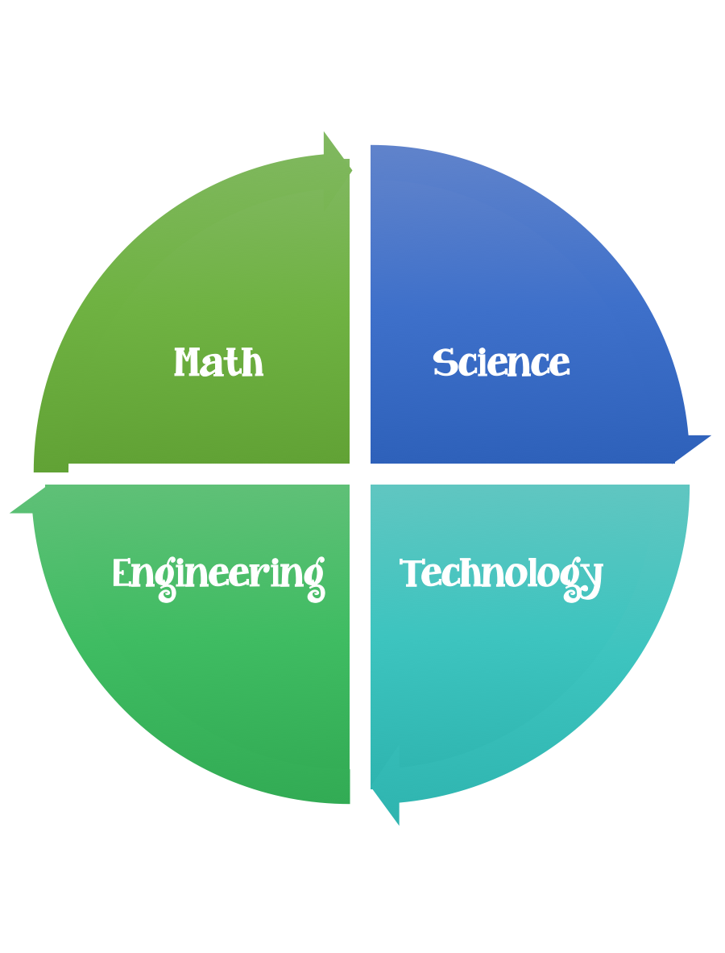
Findley Oaks STEM
4th Grade Design Brief

Classroom  Web of Life | Unit  Organisms and Ecosystem

Standard: Prioritized Standard: S4L1.d Obtain, evaluate, and communicate information about the roles of organisms and the flow of energy within an ecosystem. Use printed and digital data to develop a model illustrating and describing changes to the flow of energy in an ecosystem when plants or animals become scarce, extinct, or over-abundant.
Students should follow the Engineering Design Process.
Background/Problem:
A food web is the natural interconnection of food chains and a graphical representation of what-eats-what in an ecological community. Another name for food web is consumer-resource system. Every living being is part of a food chain. Food and the animals that eat the food make up a food chain. For example, plants and grasses are food for zebras. Zebras are food for lions. Plants, zebras, and lions make up a food chain.
There are many different food chains in an ecosystem. Altogether, the food chains in the ecosystem make a food web.
What do you think might happen when a plant or animal is removed from a food web?

Design Challenge:
Food webs function best when there is an equal balance of all components. Let’s apply your math skills to this ecosystem scenario below, which involves balancing appropriate levels of producers and consumers including grass, deer, rabbits, hawks, and bears.
A simple ecosystem consists of ample grass, a herd of 50 deer, a nest of 2000 rabbits, a cast of 10 hawks and a sleuth of 5 bears. Deer and rabbits are herbivores, hawks only eat rabbits and bears eat both deer and rabbits.
Draw a food web, showing how the animals in this ecosystem are fed and what the transfer of energy is.
Think about what would happen to the ecosystem if...
- The deer began reproducing rapidly.
- Some of the rabbits migrated out of the area.
- The bears were hunted by humans.
The average weight of the animals in this ecosystem is given in the table below:
Animal | Weight
Deer | 150 kg
Rabbit | 1 kg
Hawk | 1 kg
Bear | 500 kg

In the autumn, a bear needs to consume as much as 40kg of food a day as it prepares for its winter hibernation. A hawk will eat up to 1kg of food at a time, although it can then go without food for a day or two.
Rabbits reproduce quickly: a single female can produce up to 800 children, grandchildren and great-grand children over a season (February to October in the northern hemisphere, July to February in the southern hemisphere).
Is this eco-system sustainable over time?
Do not check the solution until you have finished the activity.
Sustainable Ecosystem Solution
Post a picture of your solution on Flipgrid here.

