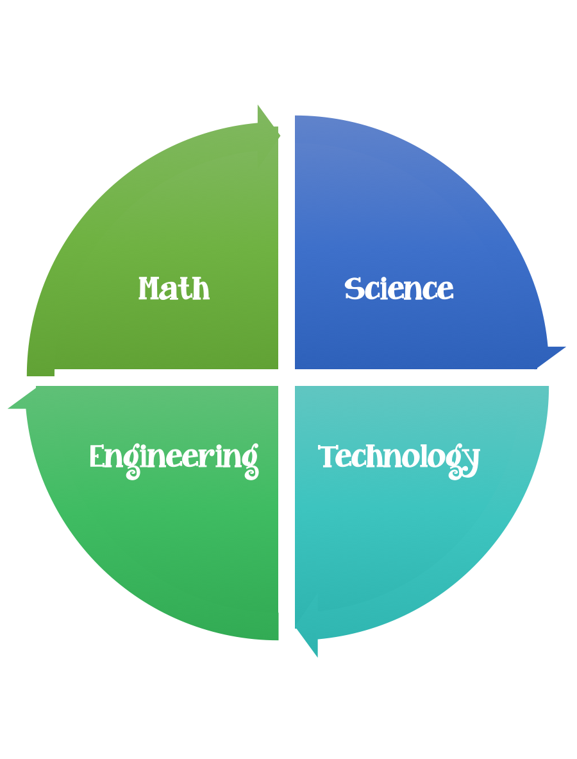
Findley Oaks STEM
3rd Grade Design Brief

Challenge  Reusable Object Project Homemade Toys | Unit  Pollution and Conservation

Standard: Prioritized Standard: S3L2.a Obtain, evaluate, and communicate information about the effects of pollution (air, land, and water) and humans on the environment.
Students should follow the Engineering Design Process.
Background/Problem: We have learned that it is a good idea to conserve the resources/things that we have. Recycle, reuse, and reduce.
Design Challenge:
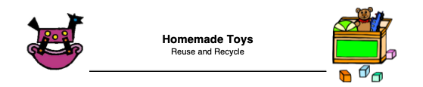
Your design challenge is to make a toy out of recyclable materials. Design and build a homemade toy that two to four children can play with together. Use as many recyclable/found materials as possible.
Children all over the world have some things in common. They all need food, shelter, and clothing. And they all love to play. Many children create their own toys with things they find in their environment. This leads to the invention of many homemade toys.

Criteria: Your creation should:
- be useable and useful.
- be strong, sturdy, and stable.
- be a toy that children around the world would like to play with
- be designed for 2 to 4 children to be able to play with together
- be constructed mostly out of recycled/found materials
- be safe to play with
- be easy to carry

Constraints:
- Make sure you have a design plan before you start.

Materials:
Clean reusable Recyclable/found items Start collecting
Straws
Craft sticks
Pipe cleaners
String
Glue
Tape
Used paper clips
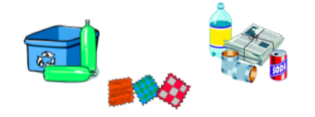

Tools:
Scissors
Stapler
Hole punch
Ruler
Crayons
Markers
Paper/pencil for design planning

Design ideas:

