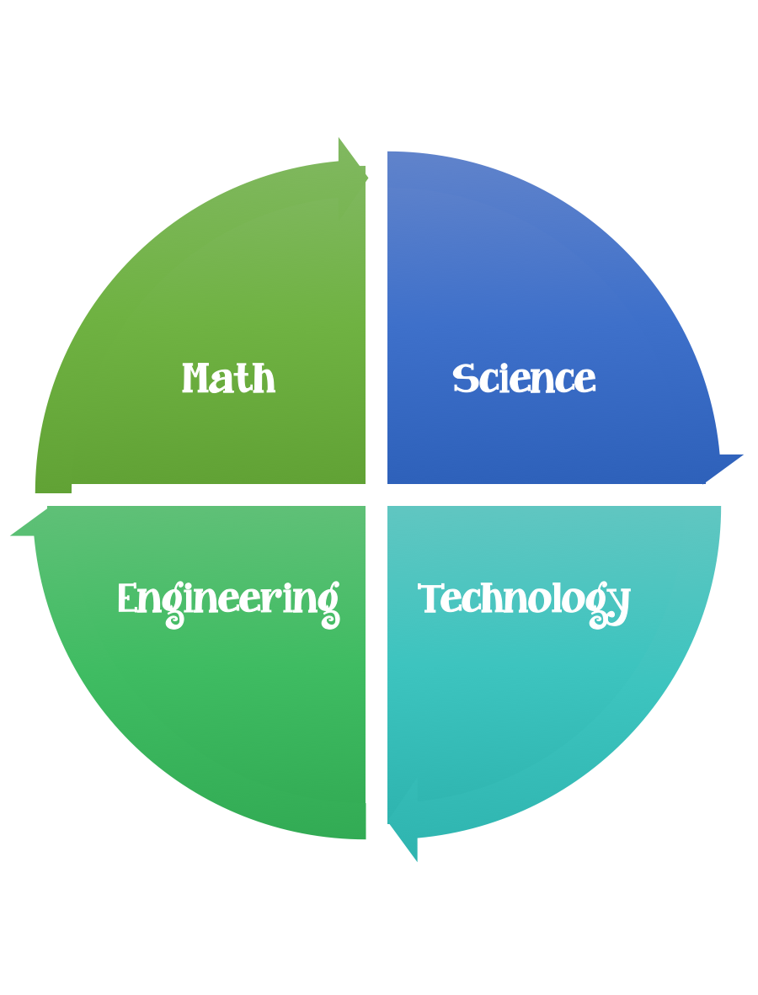
Findley Oaks STEM Connect
3rd Grade Design Brief

Challenge  Water Filter | Unit  Pollution

Standard: Prioritized Standard: S3L2.a Obtain, evaluate, and communicate information about the effects of pollution (air, land, and water) and humans on the environment. Ask questions to collect information and create records of sources and effects of pollution on the plants and animals of Georgia.
Students should follow the engineering design process.
Background/Problem: Engineers are always trying to find ways to improve things/make things better. Being able to provide clean water to people around the world is challenging.
Design Challenge: Water engineers need to invent a filter to clean dirty water.
Criteria: Your water filter should:
- be able to filter dirty water
- be made out of the materials provided or you may use only two to make it more challenging
- Make a prediction and a plan before you start

Constraints:
- You can use some or all of the materials.

Materials:
- 2 – liter soda bottle cut in half (by an adult)
- napkins or paper towels
- gravel, sand, and cotton balls for you filter
- rubber bands
- coffee filters
- dirty water – you can make it by adding cooking oil, food coloring, pieces of paper, and tiny pieces of Styrofoam to water

Tools:
- Scissors
- Water Tub/Container to build in
- Paper/pencil for design planning

Options:
- Put the top half of the soda bottle upside-down (like a funnel) inside the bottom half. The top half will be where you build your filter; the bottom half will hold the filtered water.
- Layer the filter materials inside the top half of the bottle. Think about what each material might remove from the dirty water and in what order you should layer the materials. For an added challenge, use only two of materials to build your filter.
- Pour the dirty water though the filter. What does the filtered water look like?
- Take the filter apart and look at the different layers. Can you tell what each material removed from the water?
- Wipe the bottle clean and try again. Try putting materials in different layers or using different amounts of materials.

