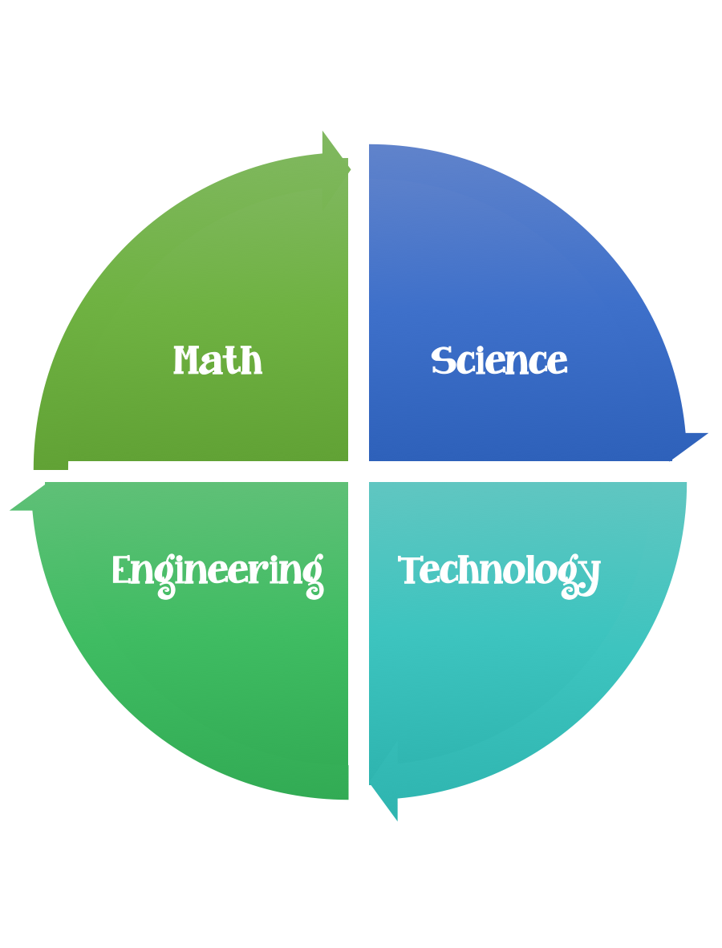
Findley Oaks STEM Connect
3rd Grade Design Brief

Challenge  Invisible Forces | Unit  Magnets

Standard:
3-PS2-1. | Plan and conduct an investigation to provide evidence of the effects of balanced and unbalanced forces on the motion of an object.
Students should follow the Engineering Design Process.
Background/Problem:
To change a spacecraft's speed and direction, NASA engineers use a planet's or moon's gravity, a process called a "gravity assist." Many spacecrafts fly close by a planet or moon to use its gravitational pull to change speed and direction. This “gravity assist” also greatly reduces the fuel required to navigate a spacecraft.

In this video from Design Squad Nation, kids design and build systems that use magnets to control the speed and direction of a rolling ball.
As they build their systems, the kids use the engineering design process, apply a variety of science concepts (e.g., force, magnetic fields, inverse square law), and learn how NASA spacecraft use gravity to help them explore the solar system.

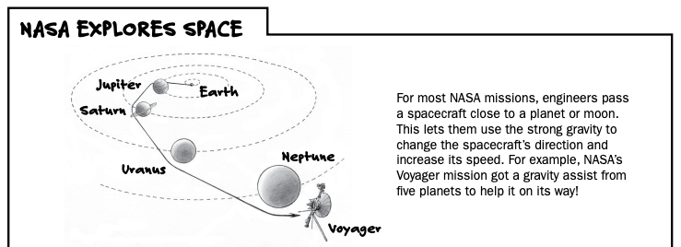

Design Challenge:
Build a system that uses magnets to control the speed and direction of a rolling ball.
Introduction:
Explain that gravity is a force present in all things and that planets and moons exert a gravitational pull on spacecraft that pass close by.
Spacecraft use small onboard rockets to make minor course corrections.
Big corrections require a lot of fuel, which is heavy to carry. Instead of using rockets, NASA engineers use a planet’s or moon’s gravity to increase a spacecraft’s speed and “steer” it by changing its direction. This process is called a “gravity assist.”

• Tell kids that today they will do something similar to what NASA does, but instead of using gravity to steer a ball, they’ll use a magnetic force. Then show kids the Invisible Force video.

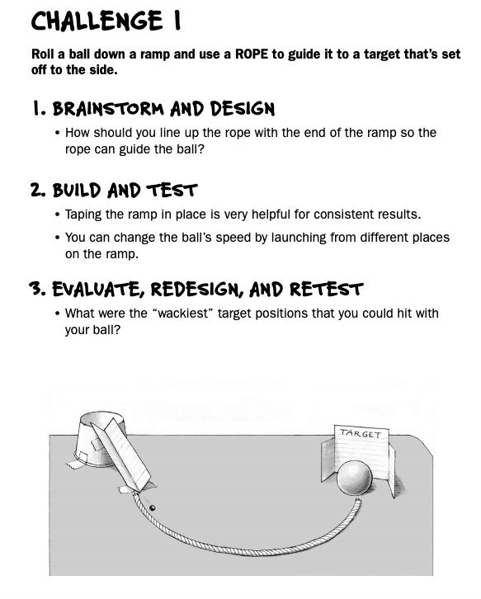

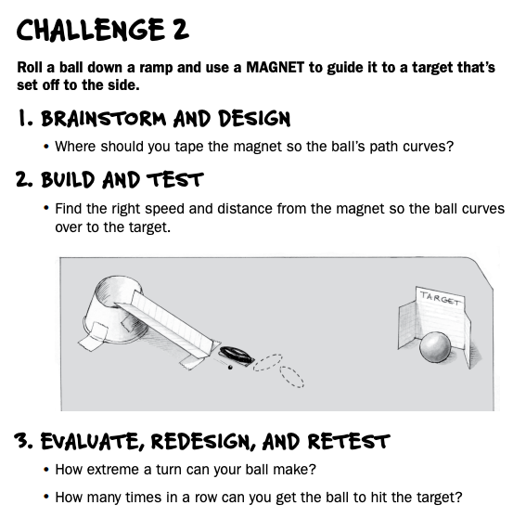

Constraints:

Make sure you have a design plan before you start.

Materials:
Paper cup (6- to 8-ounce)
• Strip of index card (2.5 x 12.5 centimeters) [1 X 5 inches])
• 30-centimeter (12-inch length of flexible rope/clothesline)
• 1 steel ball (60-millimeter [quarter inch] ball bearing)
• 1 strong magnet The best magnets for this activity are the silver, three-inch-long, oblong magnets sometimes called “cow” or “snake-egg” magnets.

• 1 target (e.g., “X” of tape on the table or an object to hit)
• Tape (any kind)
- Paper/pencil for design planning

Tools:
Scissors
Crazy scissors
Staplers
Hole punch
Rulers

