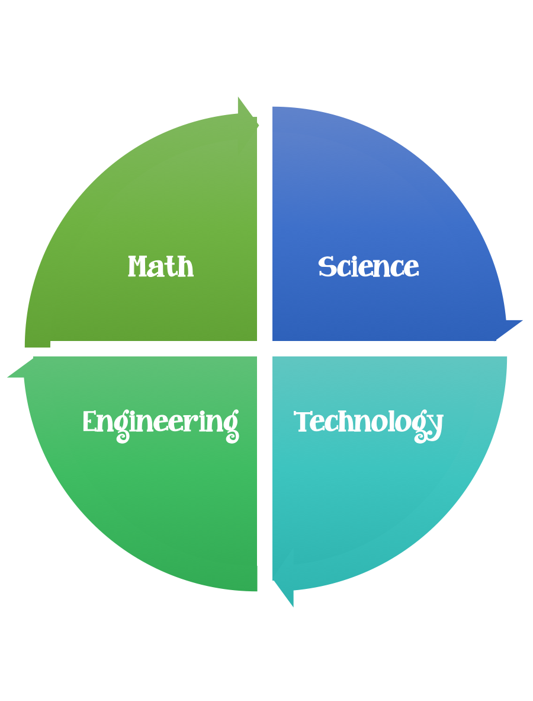
Findley Oaks STEM Connect
3rd Grade Design Brief

Challenge  Bird’s Nest | Unit  Georgia Habitats

Standard: Prioritized Standard: S3L1.b Obtain, evaluate, and communicate information about the similarities and differences between the habitats found within geographical regions (Blue Ridge Mountains, Piedmont, Coastal Plains, Valley and Ridge, and Appalachian Plateau) of Georgia. Identify external features and adaptations (camouflage, use of hibernation, protection, migration, mimicry) of animals to construct an explanation of how these features/adaptations allow them to survive in their habitat.
Students should follow the engineering design process.
Background/Problem: Birds build their habitats out of natural resources that they find outdoors. They use mud, sticks, straw, twigs, leaves, feathers, and grass.
Design Challenge: Your design challenge is to build a bird’s nest out of the materials listed and see how many eggs it can hold.
Criteria: Your nest should:
- be shaped like a bowl.
- be made out of mud, twigs, sticks, grass, feathers, and leaves.
- be as strong as possible.
- be between 5 and 10 centimeters tall.
- Be at least 5 centimeters wide.

Constraints: You can use some of are all of the materials.
Test out your nest by placing it in a low branch of a tree, or you can tape 3 rulers or yardsticks together into a triangle to simulate a tree branch. Place hard-boiled eggs in it.
How many can it hold?

Materials:
Mud
Straw
Grass
Twigs
String
Sticks
Leaves
Feathers
6 Hard boiled eggs for testing –how many can your nest hold?

Tools:
Markers/crayons
Stapler
Hole punch
Rulers
Scissors
Crazy scissors
Glue and/or Glue Sticks
Sticks (a footlong) or rulers for testing
Paper/pencil for design planning

Options: weigh your nests, measure you nests, weigh the eggs.

