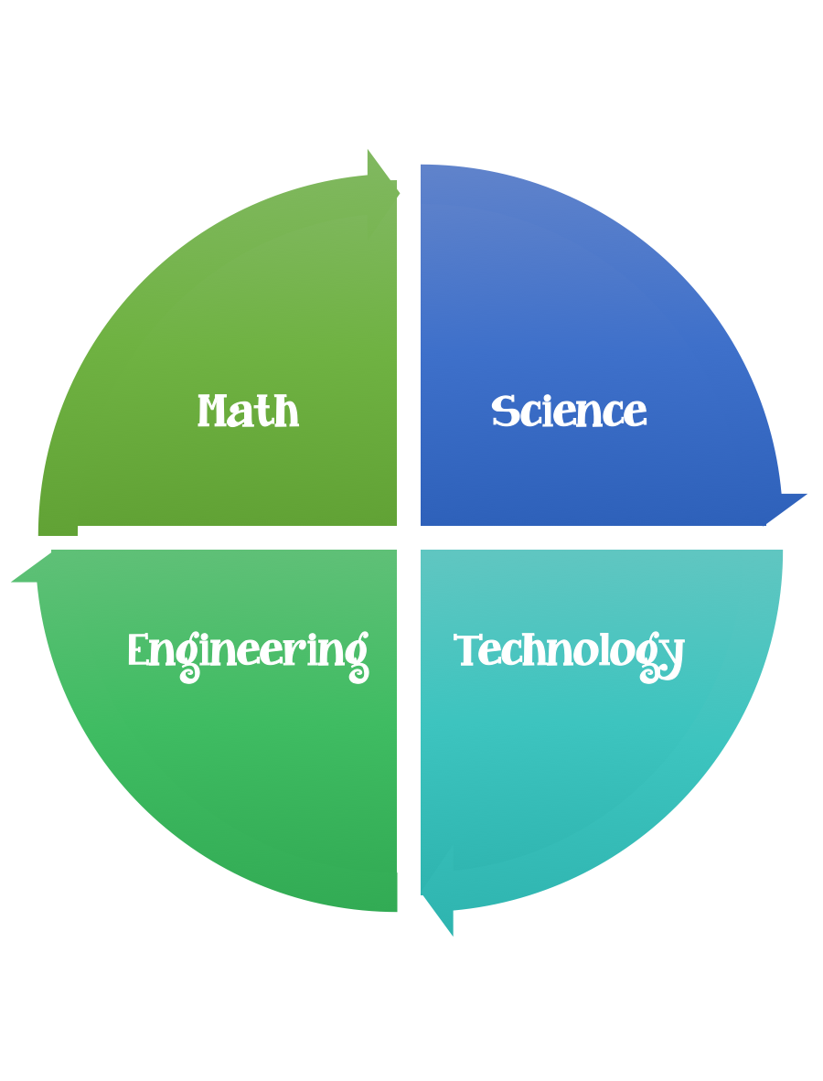
Findley Oaks STEM
3rd Grade Design Brief

Challenge  Erosion | Unit  Rocks and Soil

Standard: Prioritized Standard: S3E1.a Obtain, evaluate, and communicate information about the physical attributes of rocks and soils. Ask questions and analyze data to classify rocks by their physical attributes (shape, color, texture, luster, and hardness) using simple tests.
Students should follow the Engineering Design Process.
Background/Problem:
Erosion is the movement of weathered materials from one location to another. For example, if wind blows beach sand from a dune and scatters the sand over a beach parking lot, the sand is said to have been eroded. The formation of the Grand Canyon is an example of water eroding the land over millions of years. Agents of erosion include moving water, wind, gravity, and animal traffic.
Weathering is the chemical or physical breakdown of rock into smaller pieces. A number of different agents’ weather rock including water, wind, gravity, animal traffic, and the freezing and thawing process.
A number of factors can affect the rate at which erosion occurs. Some of these factors are particle size, speed of the agent of erosion, and the type of erosion agent.

People have devised numerous methods for reducing erosion. Some of these methods include:
- terracing (cutting stair steps into the side of a hill)
- planting ground cover (like turf and bushes),
- building retaining walls
- creating less severe slopes
- and using soil lifts, which are similar to sandbags.
Some methods of erosion prevention are more effective than other methods.

Design Challenge:
You have been tasked with building a level basketball court at Findley Oaks Elementary. Unfortunately, the only piece of land large enough to locate your court is on a steep hillside. You'll have to come up with an erosion control plan that keeps the land from washing over your court during heavy rainfalls. Are you up for the challenge? The ball is in your court
Criteria:

Your creation should
- be useable and useful.
- be strong, sturdy, and stable.

Constraints:

- Make sure you have a design plan before you start.

Materials:
- simulation of river flow, a homemade erosion table
- small-size model buildings, made out of LEGO
- 10 pounds fine sand
- water, sink, and buckets

Tools:
- Scissors
- Crazy scissors
- Staplers
- Hole punch
- Rulers
- Paper/pencil for design planning

