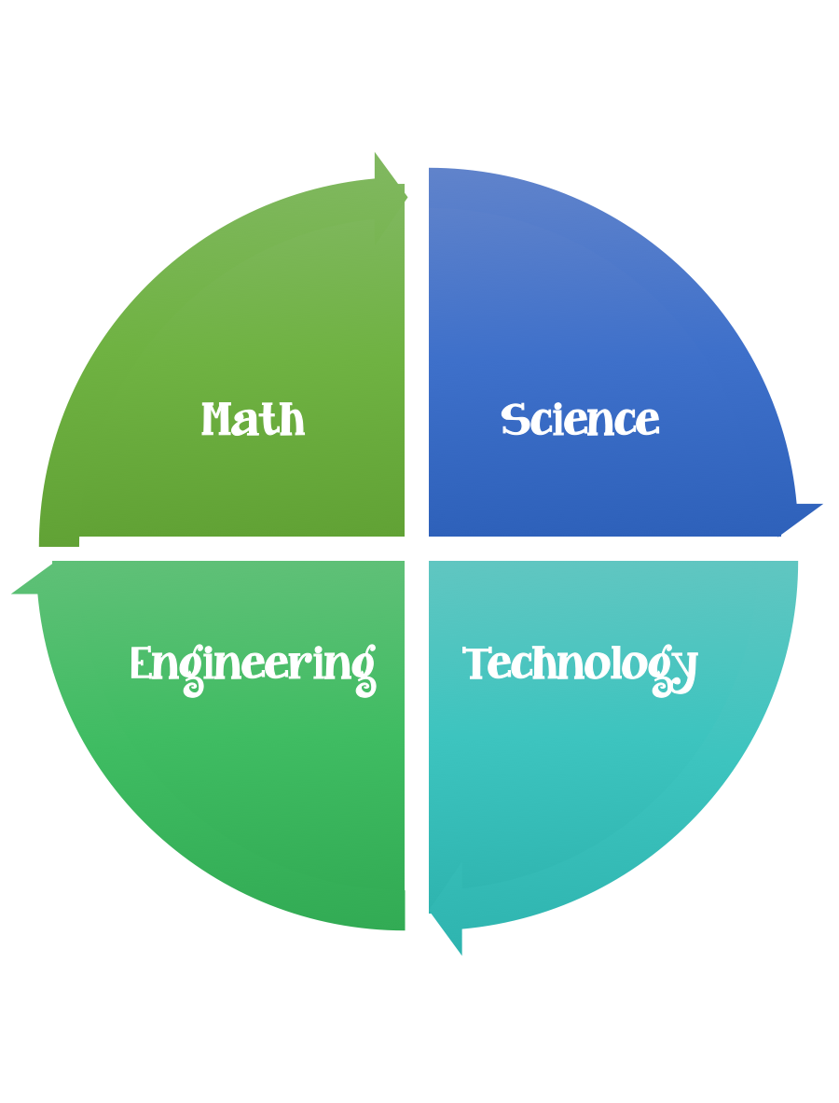
Findley Oaks STEM Connect
3rd Grade Design Brief

Challenge  Mining Resources | Unit  Pollution and Conservation

Standard: Prioritized Standard: S3L2.a Obtain, evaluate, and communicate information about the effects of pollution (air, land, and water) and humans on the environment. Ask questions to collect information and create records of sources and effects of pollution on the plants and animals of Georgia.
Students should follow the engineering design process.
Background/Problem: Some of the resources we use are found underground. To reach valuable rocks and minerals, people dig mines. In Georgia, we mine for kaolin (a type of clay) which we use for making paper. However, mining can impact the environment around it. Investigate to find out more.
Design Challenge: Your design challenge is to remove all of the chocolate chips from a cookie with as little damage as possible. (Mine the resources from the land with as little damage as possible). Estimate how many chocolate chips you might find before you begin.
Criteria: Your cookie must:
- Be mined very carefully, with as little damage as possible to the cookie.
- Limited to two cookies (one for testing, one for the redesign testing).
- Do not eat the cookie or the chocolate chips that were used in the experiment.

Constraints:
You may only use your paperclip designed tool or a toothpick to extract the chocolate chips (no hands allowed).

Materials:
2 Chocolate Chip Cookies

Tools:
Small cup of water with dropper
Paper plate
Toothpick
Paperclip

Paper/pencil for design planning

Options: Oatmeal raisin cookies may be used if there are food allergies.

