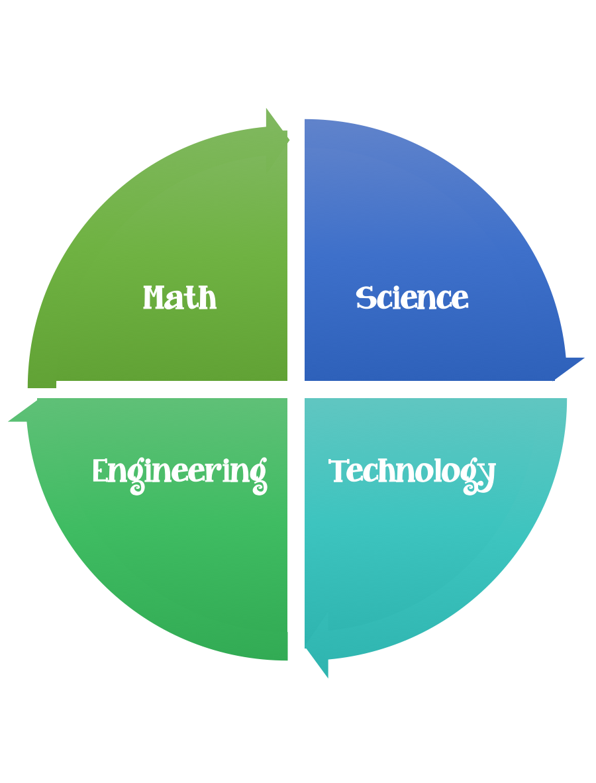
Findley Oaks STEM Challenge
2nd Grade Design Brief

Challenge  Seasons Tree | Unit  Causes of Change

Standard: Prioritized Standard: S2E2.a Obtain, evaluate, and communicate information to develop an understanding of the patterns of the Sun and the moon and the sun’s effect on Earth. Plan and carry out an investigation to determine the effect of the position of the sun in relation to a fixed object on earth at various times of the day.
Students should follow the Engineering Design Process.
Background/Problem: Winter, spring, summer, and fall. What happens to a tree during these four seasons? Your teacher needs your help making a presentation to demonstrate these changes to other students in the school.
Design Challenge: Your challenge is to create/design a tree that represents a season and is free standing. The tree should have a form of participation and/or another element that matches the season of the tree. (example: raindrops, snowflakes, buds, or fruit)
Criteria:
Your tree should:
- be free standing (cannot be attached to the table- must be able to be moved)
- represent one of the four seasons
- have one attribute that relates to the season
- be three dimensional
- have a trunk
- have at least three branches
- be taller than 5 unifix cubes (5 inches) and shorter that 12 (12 inches)

Constraints:
You can only use the materials provided.
Materials:
- brown lunch bags
- felt (pink, white, light blue)
- assorted construction paper colors
- 10 centimeters of tape
- yarn (brown and green)
Tools:
- markers and / or crayons
- scissors
- hole punch
- unifix cubes or ruler
- paper and pencil for design planning

Make a list of the attributes of your seasonal tree and be able to explain/share with your class.
