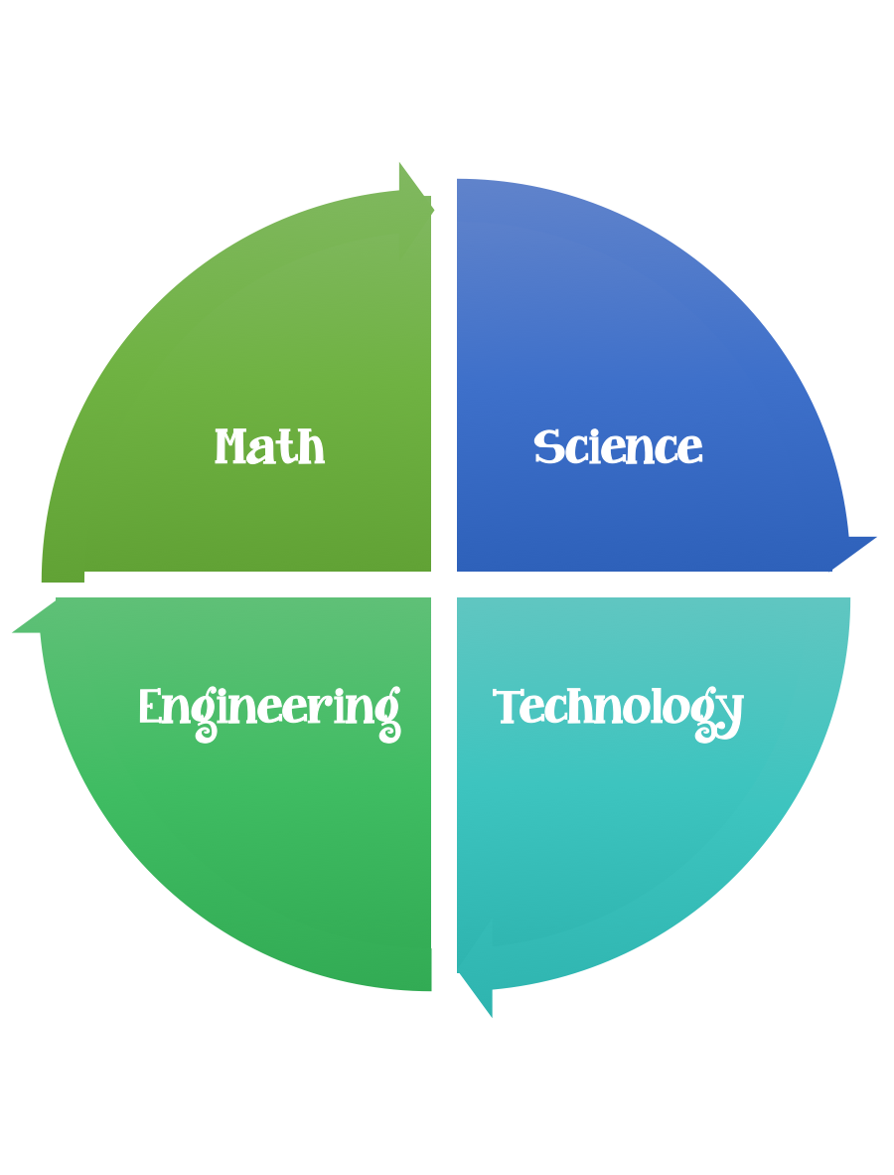
Findley Oaks STEM Challenge
2nd Grade Design Brief

Challenge  Operation Top Secret  Message | Unit  Pushes and Pulls

Standard: Prioritized Standard: S2P2.c Obtain, evaluate, and communicate information to demonstrate changes in speed and direction using a force (a push or a pull). Record and analyze data to decide if a design solution works as intended to change the speed or direction of an object with a force (a push or a pull).
Students should follow the Engineering Design Process.
Background/Problem:
Cinderella has been locked in the tower of her castle by the evil queen.
Design Challenge:
Your challenge is to relay a “Top Secret Message” to the princess locked in the tower. You need to build a contraption to deliver the message safely.
Criteria:

Your contraption needs to:
- be able to deliver a message to the princess
- have a moving part
- be as tall as possible
- be free standing and portable

Constraints:

- You can use some of are all of the materials.

Materials:

- 10 pieces of paper
- 10 paper clips
- 10 rubber bands
- 20 feet of string
- 3 feet of masking tape

Tools:
- rulers
- scissors
- paper/pencil for design planning

