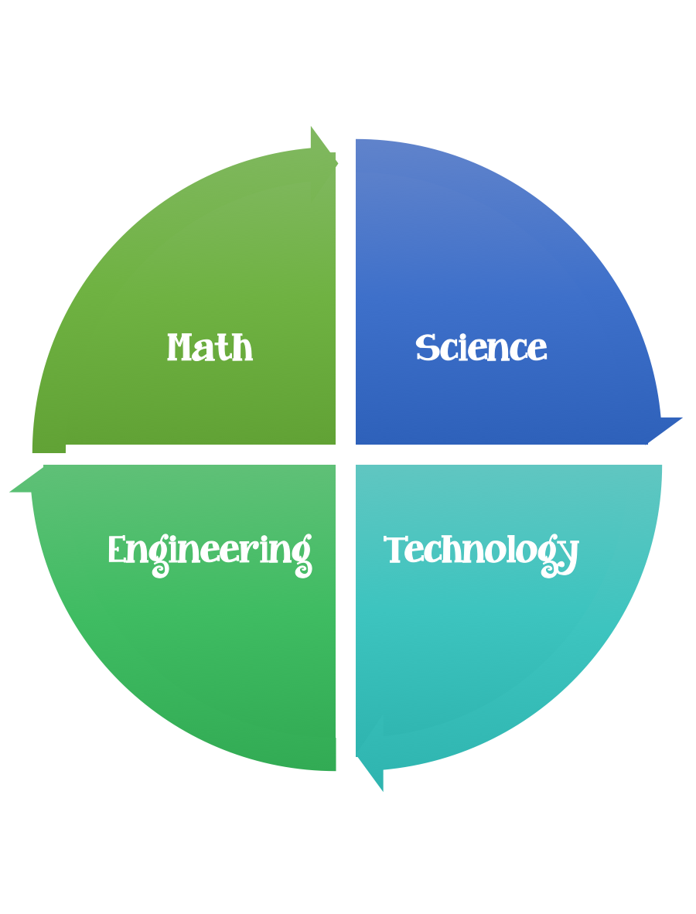
Findley Oaks STEM
2nd Grade Design Brief

Challenge  Pop Rockets | Unit  Physical Attributes of Stars

Standard: Prioritized Standard: S2E2.a Obtain, evaluate, and communicate information to develop an understanding of the patterns of the Sun and the moon and the sun’s effect on Earth. Plan and carry out an investigation to determine the effect of the position of the sun in relation to a fixed object on earth at various times of the day.
Students should follow the Engineering Design Process.
Background/Problem:
We have been learning about the stars and the sun. Wouldn’t it be fun to travel in a rocket to get a closer look? What is a star? Let’s review the attributes that we have been learning about.
Design Challenge:
NASA needs your help designing a rocket to explore the stars with. Can you help?
Your challenge is to create/design a pop rocket that we can pretend to get a closer look at the stars and explore them for NASA.
Criteria:

Your rocket should:
- be decorated
- have a name
- have one or more-star attributes written on it

Constraints:
You can only use the materials provided.
(Remember that this science experiment uses antacids which can contain aspirin so that normally we should not play with these without an adult.)

Each student should launch their rocket twice and predict how far/high it will travel.

Materials:
- Mini M&M tubes (empty with the labels removed and the tab that holds the top on completely cut off.)
- Antacid tablets
- Cardboard – cereal boxes work great, used to make the mini cones for the top of the rockets. (can be made ahead)
- Heavy duty aluminum foil
- Decorations (asst. stickers) optional
- Washi tape – decorative colors
- Painters tape
- Clay – small ball each –to put under the lid the hold the tablet in place.
- 1 teaspoon of water
- piece of wood to use as a launching pad
Tools:
Glue--- Glue gun – parent assisted
- markers and / or crayons
- scissors
- hole punch
- teaspoons
- meter sticks
- paper and pencil for design planning

Instructions:
- decorate the canister
- make the cone and cover in aluminum foil
- have an adult attach to the bottom of the canister (the side opposite the cap with the hot glue gun)
- measure and pour 1 teaspoon of water into the rocket and then attach the top/lid.
- Once the lid has been placed snugly on the rocket, flip it over onto a wooden board (placed outside on the grass) and run for cover.
- Launch twice and measure the distance. Take notes of what you observed.

The Science Behind It
- When the water and the antacid mixed together a carbon dioxide gas was produced.
- By placing the lid on the rocket, you trapped those gas bubbles inside.
- As more and more bubbles were produced, the pressure inside the rocket builds, creating enough force to break the seal on the lid.
- There was so much force from the built-up pressure that it launched the rocket into the air.

