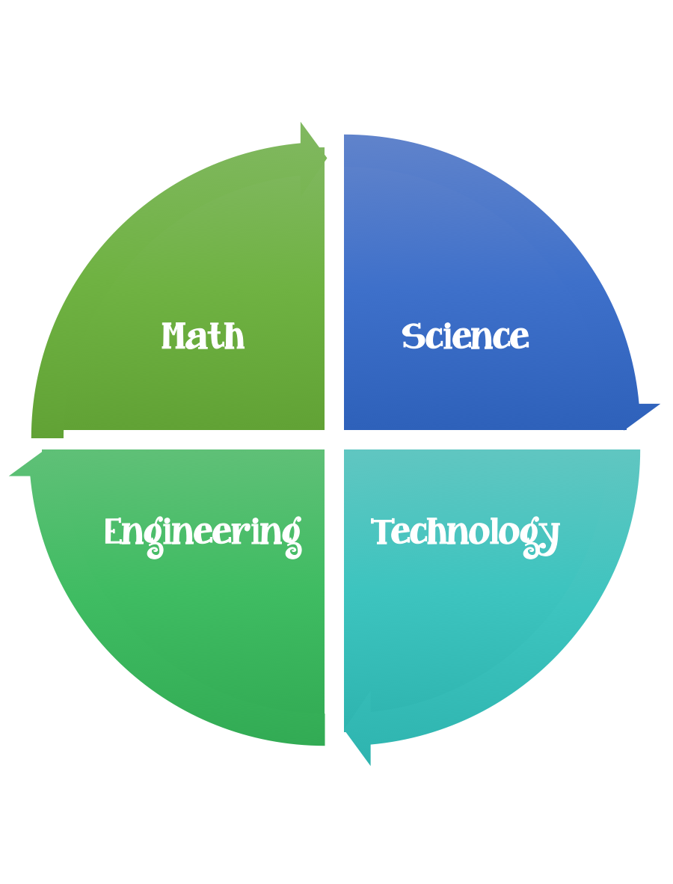
Findley Oaks STEM Challenge
2nd Grade Design Brief

Challenge  Don’t Lose Your Peaches | Unit  Forces of Energy

Standard: Prioritized Standard: S2P2.c Obtain, evaluate, and communicate information to demonstrate changes in speed and direction using a force (a push or a pull). Record and analyze data to decide if a design solution works as intended to change the speed or direction of an object with a force (a push or a pull).
Students should follow the Engineering Design Process.
Background/Problem:
A shipment of Georgia Peaches (marbles) from the producers need to be delivered efficiently to the consumers. The engineers working on this project need your help designing a conveyer belt.
Design Challenge:
Your challenge is to create/design a free-standing structure that has a track on which the peaches can travel.
- You will be awarded points for the height of the structure at the point where the marble begins its ascent down the track.
- Points will also be awarded for each right angle turn in the track.
- You will be allowed 5 marble runs.
- You will start each marble at the top of the track and let it go.

- You will receive points for each marble that successfully travels all the way down the track. Additional points will be awarded for marbles caught in a container at the end of the track. You will receive points for meeting the following criteria.

- 1 point – for each centimeter of height
- 5 points – for each 90-degree angle turn in the track
- 1 point – for each marble that successfully travels the entire length of the track, but dos not land or stay in a container at the end of the track.
- 5 points – for each marble that travels the track and stays in a container at the end of the track.

Criteria:

Your conveyer belt should:
- have a start and a stop point
- have at least 4 angles in it
- the peaches (marbles) must drop into a cup at the end
- travel without stopping.
- be at least 30 centimeters tall

Constraints:

- you will be allowed 5 marble rolls
- each marble must start at the start line
- if the structure breaks, make repairs or start again
- the structure must remain standing when completed
- you have 30 minutes to complete your build

Materials:

- 6 straws
- 10 Q-tips
- 6 index cards
- ½ stick modeling clay
- 12” inches of masking tape
- 1 small paper cup
- 1 marble
- 1 copy paper/shoe box lid (Any box lid that has sides can be used

Tools:

- rule
- paper/pencil for design planning
- scissors

