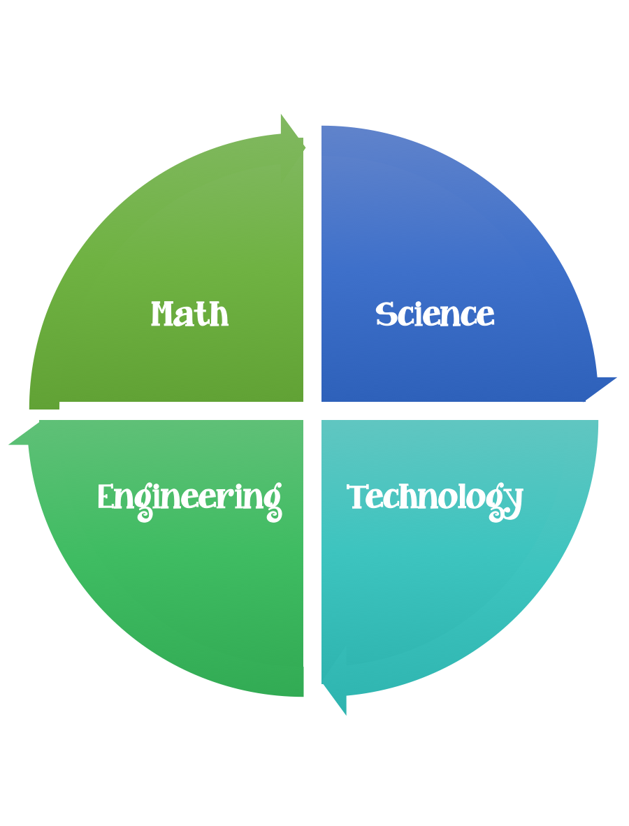
Findley Oaks STEM Challenge
2nd Grade Design Brief

Challenge  Tissue Paper  Life Cycle Collage | Unit  Life Cycles

Standard: Prioritized Standard: S2L1.b Obtain, evaluate, and communicate information about the life cycles of different living organisms. Plan and carry out an investigation of the life cycle of a plant by growing a plant from a seed and by recording changes over a period of time.
Students should follow the Engineering Design Process.
Background/Problem:
We have been learning about life cycles. Your teacher needs your help teaching others about four stage life cycles by creating a collage. Can you help?

Design Challenge:
Your challenge is to pick an insect or animal that has four stages and design a collage out of tissue paper that is torn and made to represent each stage.
Criteria:
Your collage needs to:
- contain the life cycle stages
- be made out of tissue paper
- be glued onto a transparency/piece of GLAD press and seal so that when you put it on a window the light can shine through

Constraints:

- You can use some of are all of the materials.

Materials:
- transparency paper or a 11 x 81/2 piece of GLAD press and seal
- tissue paper (assorted colors)

Tools:
- rulers
- scissors
- glue sticks
- paper/pencil for design planning

Life cycle examples:

