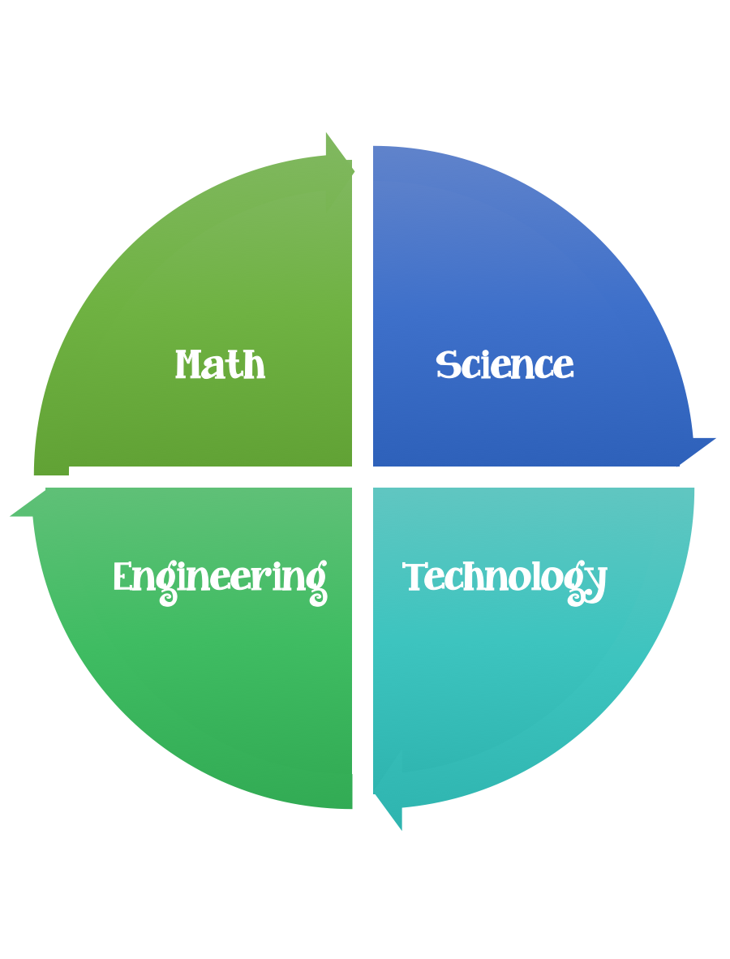
Findley Oaks STEM Challenge
2nd Grade Design Brief

Challenge  Keep a cube from melting | Unit  Properties of Matter

Standard: Prioritized Standard: S2P1.c Obtain, evaluate, and communicate information about the properties of matter and changes that occur in objects. Provide evidence from observations to construct an explanation that some changes in matter caused by heating or cooling can be reversed and some changes are irreversible. (Clarification statement: Changes in matter could include heating or freezing of water, baking a cake, boiling an egg.)
Students should follow the Engineering Design Process.
Background/Problem:
Have you ever been in a room that was too hot or too cold? Imagine that you could control the temperature so that it’s just right for you. Engineers are designing homes for the future called “smart homes”. When you enter a room, sensors will detect who you are. Then a computer will make the room temperature warmer or colder, depending on what you like.
These same engineers are trying to keep on ice cube from melting too quickly. NASA would like you to help them design a package to keep an ice cube from melting for 30 minutes. Can you help?
Design Challenge:
Your challenge is to create/design a package to keep an ice cube from melting for 30 minutes out of the materials provided.

Criteria:

Your package should:
- be able to keep a cube from melting for 30 minutes
- must be placed/put inside a box
- can be wrapped up/ or the box can be covered

Think about what makes an ice cube melt before attempting your design.

Constraints:
- You can only use the materials provided.
- A second ice cube should be placed on a paper plate. This is your “control” cube. Do not make any changes to this cube.

Materials:
- 2 ice cubes
- cardboard box
- wax paper
- masking tape
- newspaper
- aluminum foil
- rubber bands
- paper plates
- copy of attached worksheet

Tools:
- scissors
- hole punch
- timers
- paper and pencil for design planning

***After the build - Set the timer and wait 30 minutes. Compare the ice cube in your Keep-a-cube box to the ice cube on the plate.

Answer the following questions.
- Which ice cube is bigger? Why?

- How can you change the container, so the ice cube melts more slowly?

- What happens if you use a smaller box?

- Or, what happens if you use different materials, like foam packing peanuts or cotton ball? Choose one thing to change (that’s the variable) and make a prediction. Then, test it again.

Engineering Scoop:
Engineers design ways to solve problems. In this activity you designed a way to keep an ice cube from melting for 30 minutes. What makes ice melt? Heat!
The air around the ice cube is warmer that the ice. So, you need to keep the warm air away from the ice cube.
To do this, you use insulation, a material that slows heat energy from passing through it. How did you keep your ice cube from melting?

