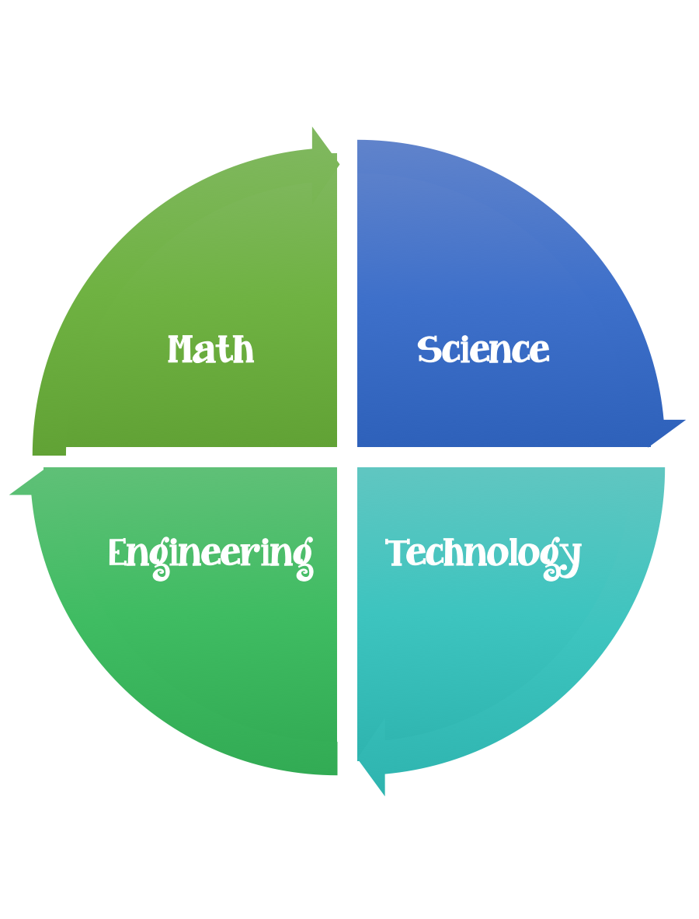
Findley Oaks STEM Challenge
2nd Grade Design Brief

Challenge  Growing Plants | Unit  Life Cycles

Standard: Prioritized Standard: S2L1.b Obtain, evaluate, and communicate information about the life cycles of different living organisms. Plan and carry out an investigation of the life cycle of a plant by growing a plant from a seed and by recording changes over a period of time.
Students should follow the Engineering Design Process.
Background/Problem:
You have learned a lot of things about plants, including the parts of a plant. You know that plants have roots, stems, leaves and flower/fruit.
Design Challenge:
Using the materials available, design and create a plant that has a stem, a flower/fruit, roots and leaves.
Criteria:

Your plant should:
- be able to stand alone
- have at least two moving parts
- have all parts labeled
- use a different material for each part of the plant
- include all 4 parts – roots, stem, leaves, and flower/fruit
- be pretty and colorful
- the flower needs to be made out of petals and contain seeds

Constraints:

- you can use some of are all of the materials

Materials:

- 1 piece of construction paper any color
- 1 craft stick
- 20 cm. of yarn
- 20 cm. of tape
- 2 brads
- 1 index card
- 2 rubber bands
- 1 pipe cleaner
- 1 toilet paper roll

Tools:

- markers/crayons
- stapler
- hole punch
- ruler
- scissors
- glue sticks
- paper/pencil for design planning

