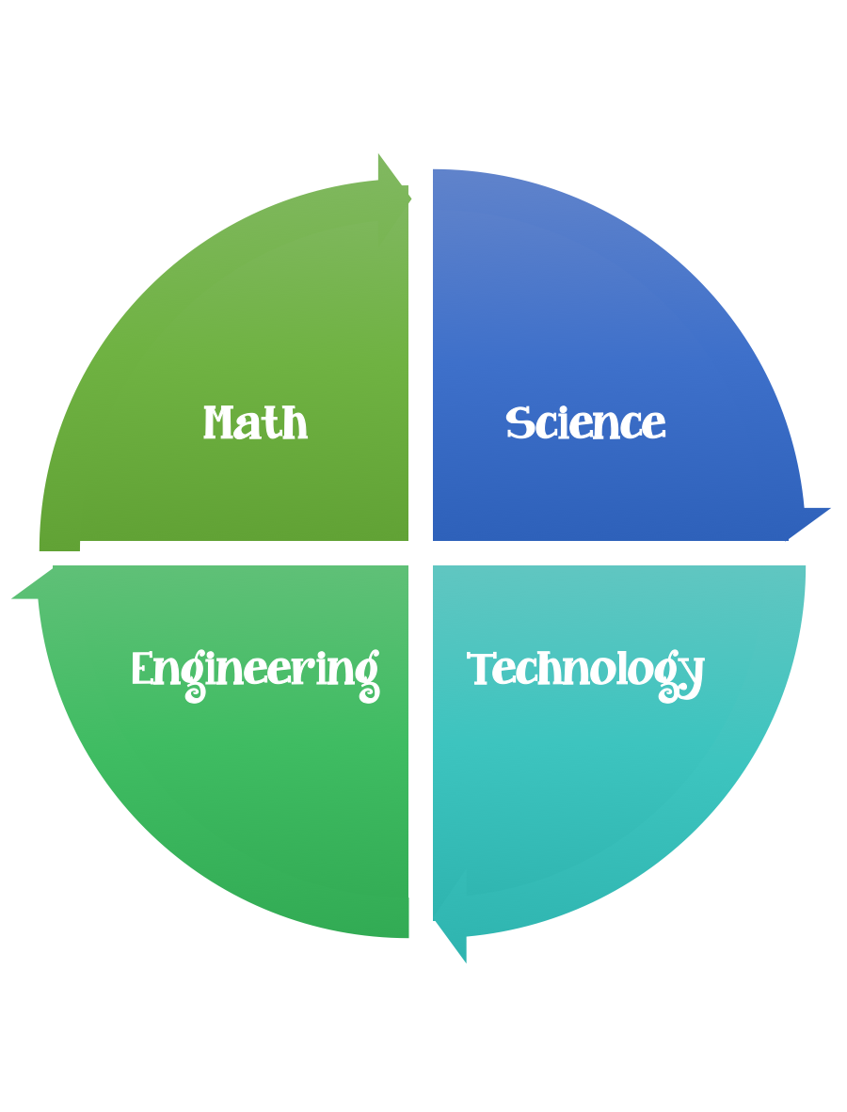
Findley Oaks STEM Connect
1st Grade Design Brief

Challenge  Musical Instrument Build | Unit  Sounds Around
Standard: Prioritized Standard: S1P1.d Obtain, evaluate, and communicate information to investigate light and sound. Construct an explanation to observe and provide evidence that vibrating materials can make sound and that sound can make materials vibrate.
Students should follow the engineering design process.
Background/Problem: The Atlanta Symphony Orchestra wants to have a celebration to honor Classical Music Month. They need your help designing musical instruments to use in the celebration.
Design Challenge: To create a musical instrument to use in the celebration using recyclable materials.
Criteria:
The instrument must be made primarily out of recycled materials, however some other materials can be used such as sticks, string, rubber bands, etc.
The instrument must be playable. This does not mean that there must be a certain or specific song played, but there must be some way to play it. This can include merely turning a “rain stick” or it can involve being able to play different pitches on bottles.

Constraints: You can only use the materials provided.
Materials:
Recycled materials such as toilet paper roles, paper towel roles, soda bottles, aluminum cans, soup cans, glass bottles, cardboard, plastic items, any others you can find
Tools:
Scissors, glue, tape, string, rubber bands, etc.
Paper (For design planning)
Pencils

See musical instrument example sheets from the Atlanta Symphony.

