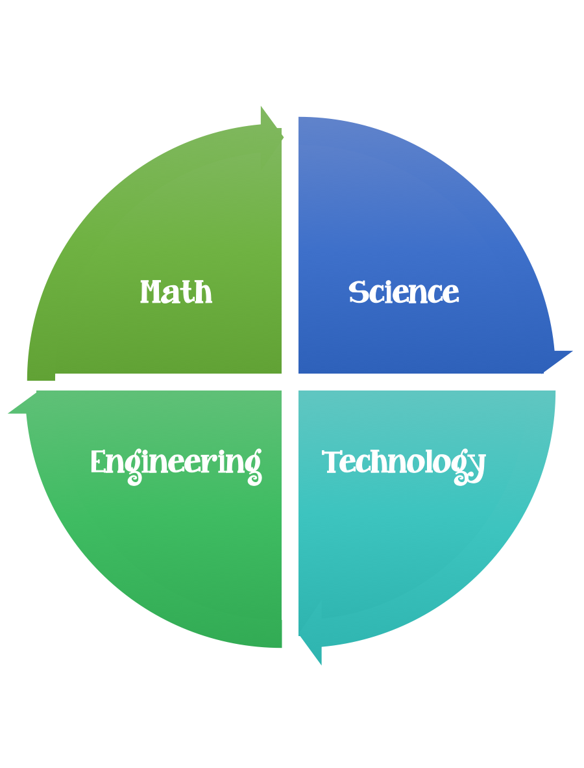
Findley Oaks STEM Connect
1st Grade Design Brief

Challenge  Tin Foil People | Unit  Light and Shadows

Standard: Prioritized Standard: S1P1.c Obtain, evaluate, and communicate information to investigate light and sound. Plan and carry out an investigation of shadows by placing objects at various points from a source of light.
Students should follow the engineering design process.
Background/Problem: The kindergarten classes at Findlay Oaks Elementary need help learning about shadows. Can you help?
Design Challenge: Students will design a figurine out of tin foil that has flat feet and attach it to a piece of tag board. The students will practice with a flashlight explaining where the shadow can be found in the morning, noon, and afternoon. The shadows will be measured using a standard or non-standard form of measurement.
Criteria: Each figurine should be made out of 4 6x6 pieces of tinfoil. The figurine needs to have a head, two arms, a body, and two legs. The figure must be able to stand up, so be sure to give it flat feet.

Constraints: Be careful with your tin foil-that is all you get. The figurine must be at least 5 unifix cubes tall and be able to stand up without falling over.
Materials:
- 4 pieces of 6x6 heavy duty tin foil Advanced students should measure and cut this themselves.
- 6x6 pieces of heavy cardboard or tag board.

Tools:
Glue
Rulers
Flashlight
Paper
Pencils

Make sure you have a plan before you begin their build.

