Findley Oaks STEM Connect
1st Grade Design Brief

Challenge  Grass Head  Recyclable Materials | Unit  Plants

Standard: Prioritized Standard: S1L1.b Obtain, evaluate, and communicate information about the basic needs of plants and animals. Ask questions to compare and contrast the basic needs of plants (air, water, light, and nutrients) and animals (air, water, food, and shelter).
Students should follow the engineering design process.
Background/Problem: Do you remember what plants need to grow? Let’s make a list.
Our classroom needs some sprucing up. Your teacher needs your help. Can you make a few grass heads to help decorate the room?
Design Challenge: Design and make your own grass head.
Criteria:
Your grass head must:
- have a nose, mouth, and two eyes.
- be dressed.
- be either a boy or girl.
- have an accessory.

Constraints: You can only use the materials provided.
Materials:
You will need:
- Old nylon stockings or pantyhose. Knee highs and pop socks, work great. You can also use regular old socks, but the grass sometimes has trouble poking through.
- Grass seeds. I bought a small "lawn repair kit" which has seeds pre-mixed with slow release fertilizer, but you can use whatever seeds you've got handy. I hear that chives, rye or alfalfa seeds also work well.

- Sawdust or potting mix for stuffing. Or just some soil from your garden. I got a bag of sawdust for free from a big hardware store - they seemed happy to get rid of it!
- Small yogurt pot.
- Decorations. Goggly eyes and fabric scraps for the heads, colored paper for the bodies, pipe-cleaners for spectacles... get creative :-)
- Water-proof glue. For sticking on the eyes, lips, etc. I used hot glue, but you can use any sort of glue so long as it won't dissolve in water.

Tools:
markers and / or crayons
scissors
crazy scissors
hole punch
staplers
rulers

Paper (For design planning)
Pencils

Instructions

Step 1: Cut off an 8" (20cm) section of stocking that includes the toe. (You could also use a "tube section" that doesn't include the toe - you'd just have to tie a knot in one end to close it, then turn it inside-out to hide the knot.)
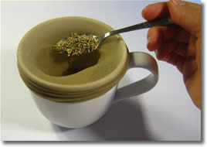
Step 2: Stretch the stocking over a large cup or mug, and spoon in about 2 teaspoons full of grass seeds.

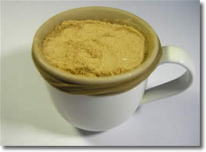
Step 3: Pack in some sawdust or potting soil. Aim for the head to be roughly tennis ball sized.
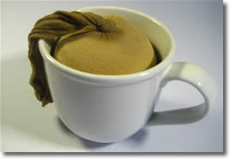
Step 4: Tie a knot to close the end. No need to cut off the dangly bit.
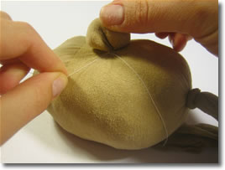
Step 5: You can make a bulbous nose or ears by grabbing a bit of stocking and twisting. Fasten base of the nose with some thread or a small rubber band.
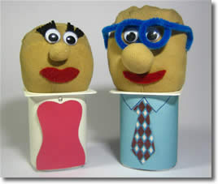
Step 6: Decorate! Use fabric scraps or permanent marker to decorate the face, and colored paper to make the yoghurt container into a dress or a suit or whatever you like - get creative! Just make sure that any glues or markers you use for the head are water-proof.

Growing your Grass Heads
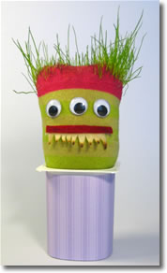
Grass grows a bit unreliably through a sock
When you're ready to grow your head, give it a good dunking in a bowl of water to moisten the sawdust/soil. Half-fill the yoghurt container with water, and put the head on top, with the excess stocking dangling down into the water.
Put your creation on a windowsill or somewhere with plenty of sunlight. Check every day to make sure the head is moist - you might need to dribble a few drops of water onto the head now and then.
"Hair" takes about 1 week to sprout. A full head of hair takes 3-4 weeks to grow, and and "greying and balding" will occur after about 6 weeks. Experiment with different hairstyles :-) You can make mohawks, pony-tails, crew-cuts... have fun with it!

