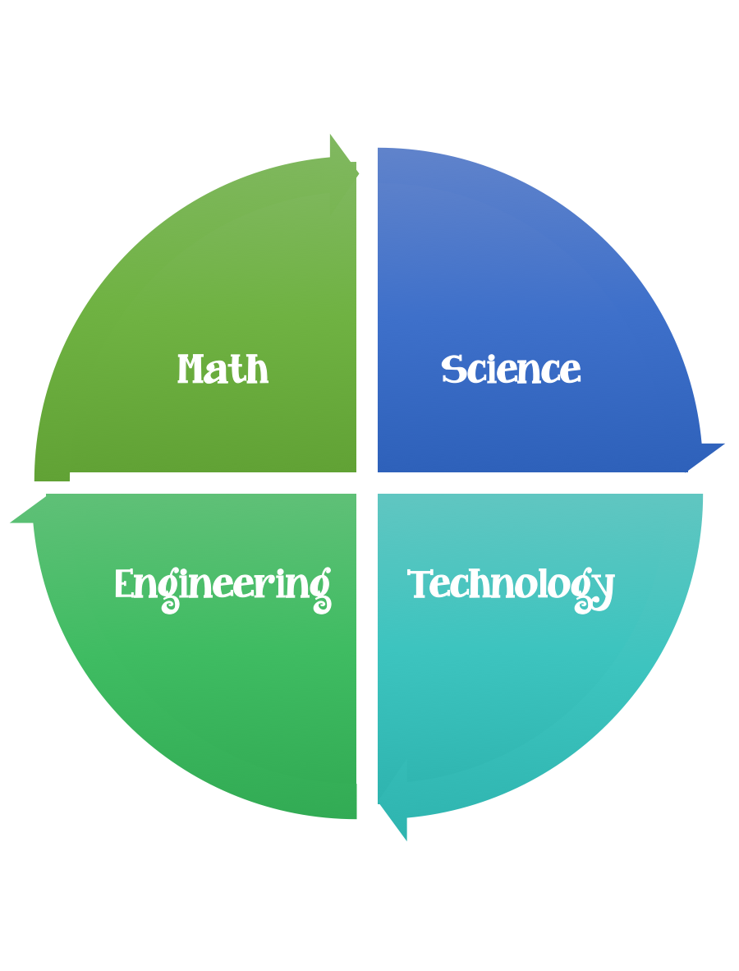
Findley Oaks STEM Connect
1st Grade Design Brief

Challenge  Magnet Maze | Unit  Magnets
Standard: Prioritized Standard: S1P2.b Obtain, evaluate, and communicate information to demonstrate effects of magnets on other magnets and other objects. Plan and carry out an investigation to demonstrate how magnets attract and repel each other and the effect of magnets on common objects.
Students should follow the engineering design process.
Background/Problem: During your study of magnets you’ve learned how they attract and repel, have a north and south pole and a magnetic field. We’ve learned which kinds of materials are magnetic.
Design Challenge: Use what you’ve learned about magnets to design and construct a magnetic maze and be able to guide an object through the maze using a magnet.
Criteria:
Your project must:
- Have a clear start and finish
- Be neat and colorful
- Include an object that is magnetic
- Include your signature on the outside of the maze

Constraints: You can only use the materials provided.

Materials: per student
- Things that are round - paper plates – different sizes – cardboard that could be cut into circles. Give students choices to select from.
- Templates/some students may be able to design a maze without a template.
- Magnets 2 each
- Cardstock
Tools:
Markers and / or crayons
Scissors

Paper (For design planning)
Pencils
Examples: Students should create their maze connect puzzles.
Dog – doghouse/bone
Bird – birdhouse
Bee – beehive
Penguin – igloo
Cat - mouse
Rabbit – carrot
Rocket ship - moon

