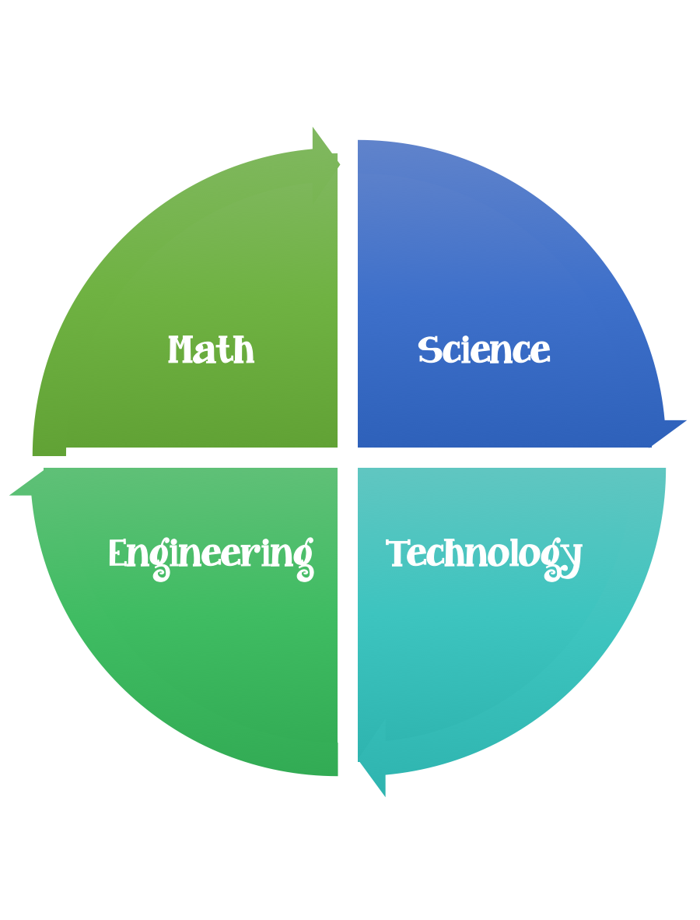
Findley Oaks STEM Connect
1st Grade Design Brief

Challenge  Butterflies are Free | Unit  Life Cycle

Standard: Prioritized Standard: S1L1.c Obtain, evaluate, and communicate information about the basic needs of plants and animals.
Students should follow the engineering design process.
Background/Problem: Watch the video of the life cycle of a butterfly.
Design Challenge: Design and make your own butterfly.
Criteria:
Your butterfly must:
- have matching wings
- have antennae

Constraints: You can only use the materials provided.
Materials:
one piece of construction paper
pompoms
ribbon
glue and/or glue sticks
pipe cleaners
brads (only to make something move or to connect parts)
toilet paper role
google eyes

Tools:
markers and / or crayons
scissors
crazy scissors
hole punch
staplers
rulers

Paper (For design planning)
Pencils

