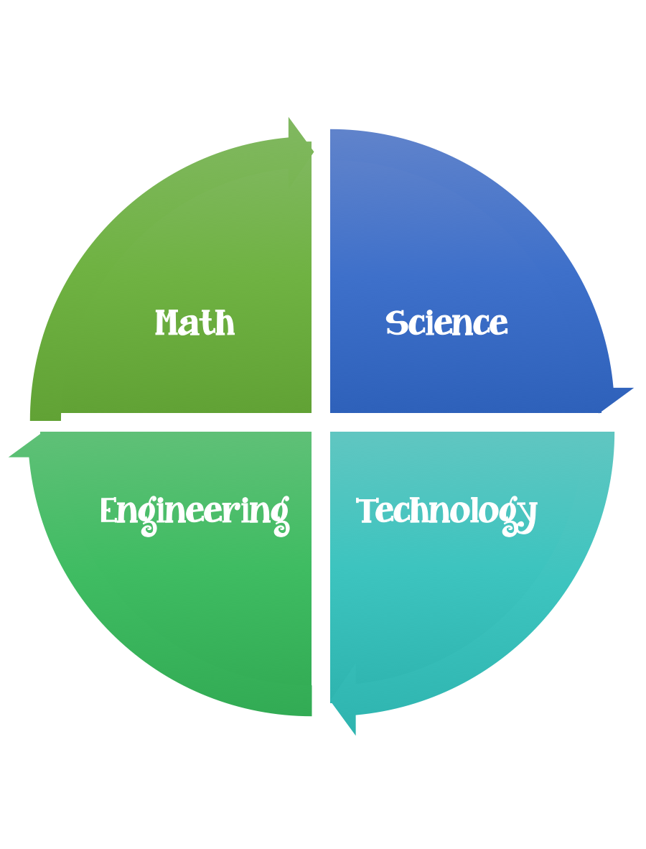
Findley Oaks STEM Connect
1st Grade Design Brief

Challenge  Build a Snowman | Unit  Weather  Changes in Water

Standard: Prioritized Standard: S1E1.d Obtain, evaluate, and communicate weather data to identify weather patterns. Analyze data to identify seasonal patterns of change.
Students should follow the engineering design process.
Background/Problem: The city hall decorators are running behind schedule. The Mayor of John’s Creek (Mike Bodker) needs help decorating City Hall. He would like for you to build really tall snowmen to put in the foyer. Can you help him?
Design Challenge: Using the materials and tools provided, design and create the tallest snowman.
Criteria:
Your snowman must:
- Be free standing and straight.
- Be made out of three pieces.
- Have two eyes
- One nose
- One mouth

Constraints: You can only use the materials provided.
Materials:
Newspaper
Toilet paper
Construction paper

Tools:
Markers and / or crayons
Scissors
Hole punch
Clear plastic packing tape
Paper (For design planning)
Pencils

Options: Add winter clothing and/or accessories hats, gloves, mittens.
Materials options:
Paper scraps
Buttons

