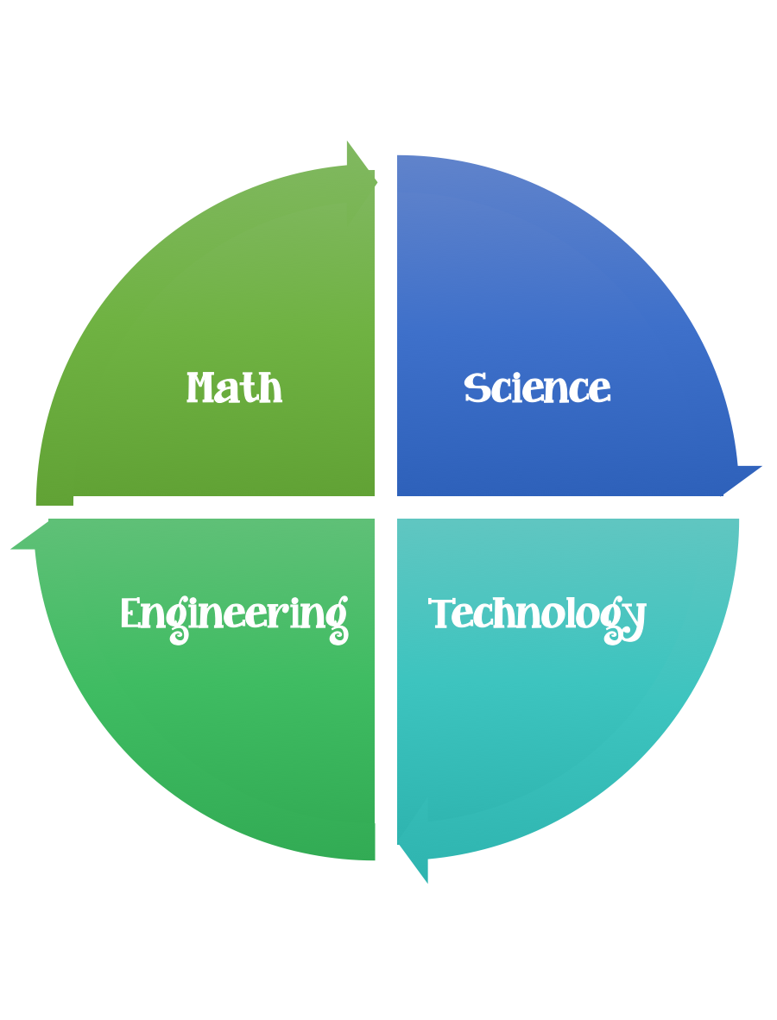
Findley Oaks STEM Connect
1st Grade Design Brief

Challenge  Traveling Pets | Unit  Animals

Standard: Prioritized Standard: S1L1.b Obtain, evaluate, and communicate information about the basic needs of plants and animals. Ask questions to compare and contrast the basic needs of plants (air, water, light, and nutrients) and animals (air, water, food, and shelter).
Students should follow the engineering design process.
Background/Problem: After reading the story about pets. You learned information about many animals that make good pets. Sometimes people need to take their pets places -on trips, to the vet, to an animal show. Your pet (favorite stuffed animal) needs a container to travel in.
Design Challenge: Design and create a container that you can use to safely and successfully carry your pet. Your pet must travel to and from safely, without falling out or getting hurt.

Criteria:
Your container must:
- have at least one moving part
- have an opening to take your pets inside and out
- have another opening so that your pets can look out and see where they are going
- have a handle so that you can carry it
- hold your pets inside, safely and comfortably
- be decorated

Constraints: You can only use the materials provided.
Materials:
Cardboard
Poster board
Boxes
Glue and/or glue sticks
Pom-poms
Toilet paper and toilet paper rolls
Rubber bands
Brads
Tape
Craft sticks
Yarn
Beads
Ribbon
Pipe cleaners
Anything in the scrap box
Construction paper
Anything else your teacher puts out for you to use

Tools:
Markers and / or crayons
Scissors
Crazy scissors
Hole punch
Staplers
Rulers

Paper (For design planning)
Pencils

